BLOG

**(HR-Employee-Attrition)**

**Submitted by:**

Homa Firdaus

**ACKNOWLEDGMENT**

I would like to convey my heartfelt gratitude to Data Trained team and my mentor for his tremendous support and assistance in the completion of my project. I would like to thank whole team for providing me with this wonderful opportunity to work on a project with the topic (HR-Employee-Attrition). The completion of the project would not have been possible without their help and insights.

**INTRODUCTION**

* BUSINESS PROBLEM FRAMING
* Every year a lot of companies hire a number of employees. The companies invest time and money in training those employees, not just this but there are training programs within the companies for their existing employees as well. The aim of these programs is to increase the effectiveness of their employees.
* CONCEPTUAL BACKGROUND OF THE DOMAIN PROBLEM

Human resource analytics (HR analytics) is an area in the field of analytics that refers to applying analytic processes to the human resource department of an organization in the hope of improving employee performance and therefore getting a better return on investment. HR analytics does not just deal with gathering data on employee efficiency. Instead, it aims to provide insight into each process by gathering data and then using it to make relevant decisions about how to improve these processes.

* REVIEW OF LITERATURE

This is a comprehensive summary of the research done on the topic Human resource analytics (HR analytics). The review should enumerate, describe, summarize, evaluate and clarify the research done.

* MOTIVATION FOR THE PROBLEM UNDERTAKEN

Attrition in human resources refers to the gradual loss of employee’s overtime. In general, relatively high attrition is problematic for companies. HR professionals often assume a leadership role in designing company compensation programs, work culture, and motivation systems that help the organization retain top employees.

**ANALYTICAL PROBLEM FRAMING**

* MATHEMATICAL/ ANALYTICAL MODELING OF THE PROBLEM
* In the data set given I there were null values available, data was skewed and outliers were also available. I tried to treat the data as per the requirement.
* DATA SOURCES AND THEIR FORMATS
* <https://github.com/dsrscientist/IBM_HR_Attrition_Rate_Analytics>
* DATA PRE-PROCESSING
* Acquire the dataset
* Import all the crucial libraries
* Import the dataset
* Identifying and handling the missing values
* Removing skew ness and Outliers
* Encoding the categorical data
* Splitting the dataset
* Feature scaling
* DATA INPUTS- LOGIC- OUTPUT RELATIONSHIPS
* In this model we have seen correlation of different feature with target variable as well as seen importance of different feature for Sales prediction.

**MODEL/S DEVELOPMENT AND EVALUATION**

* **PROBLEM STATEMENT**
* In this Project, we will try to predict Attrition factors dependency based on different features.
* Our target variable is Attrition.
* **IMPORTING IMPORTANT LIBRARIES**
* **IMPORTING DATA**
* df**=** pd**.**read_csv(r"C:\Users\Homa\WA_Fn-UseC_-HR-Employee-Attrition.csv")
* NULL value observation and and Treatment(df**.**isnull()**.**sum())
* **Used Ordinal-Encoder**

from sklearn.preprocessing import OrdinalEncoder

enc= OrdinalEncoder()

for i in df.columns:

if df[i].dtype=="object":

df[i]=enc.fit_transform(df[i].values.reshape(-1,1))

df

* **Let’s remove unwanted columns.**
* df**.**drop('EmployeeCount',

axis**=** 1,

inplace **=** **True**)

* df**.**drop('StandardHours',

axis **=** 1,

inplace **=** **True**)

* df**.**drop('EmployeeNumber',

axis **=** 1,

inplace **=** **True**)

* df**.**drop('Over18',

axis **=** 1,

Inplace **=** **True**)

* df

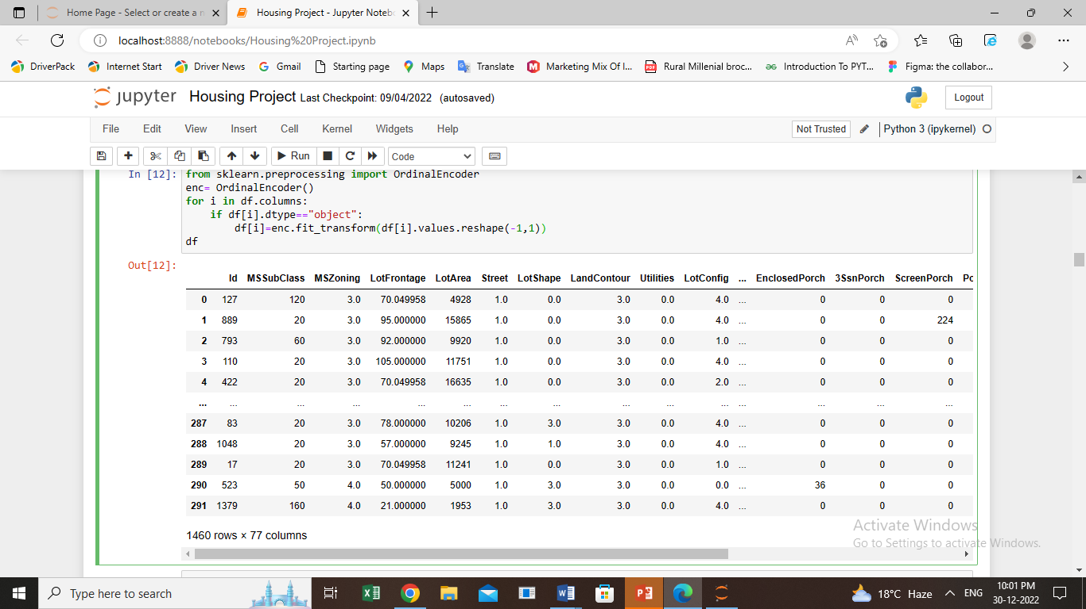

* **Let’s divide data into two features(x) and Label(y)**
* x**=**df**.**drop("Attrition", axis**=**1)
* y**=**df['Attrition']
* plt.figure(figsize=(15,130),facecolor='yellow')

plotnumber=1

for column in x:

if plotnumber<=90:

ax=plt.subplot(30,3,plotnumber)

plt.scatter(x[column],y)

plt.xlabel(column,fontsize=20)

plt.ylabel('SalePrice',fontsize=20)

plotnumber+=1

plt.show()

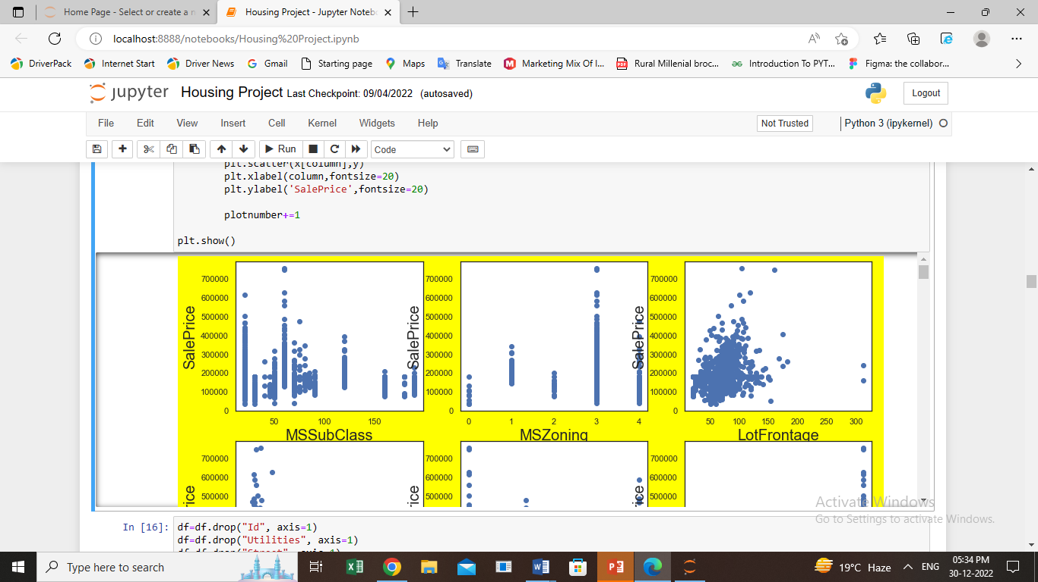

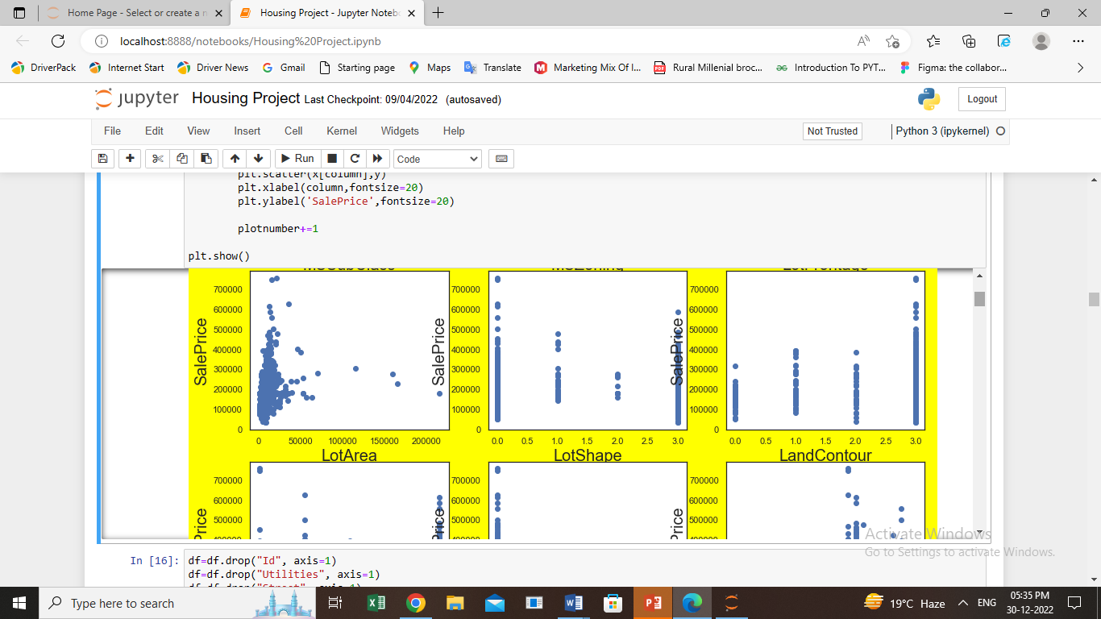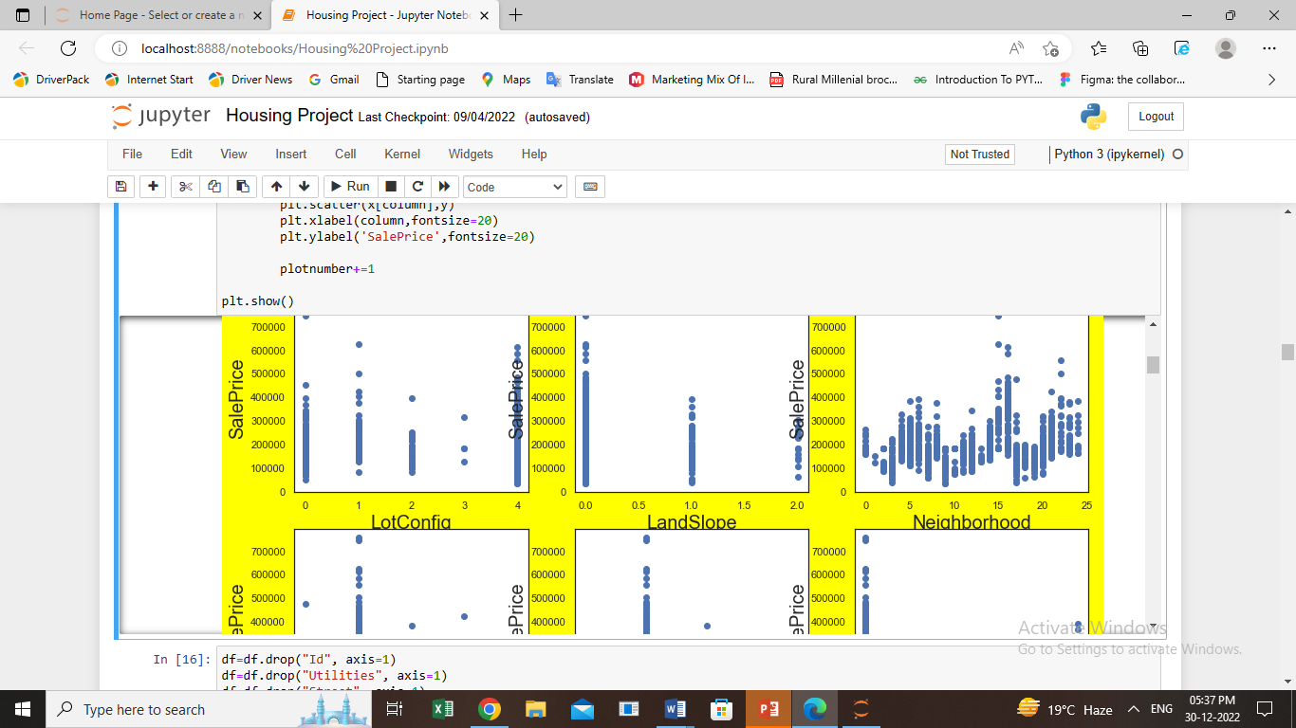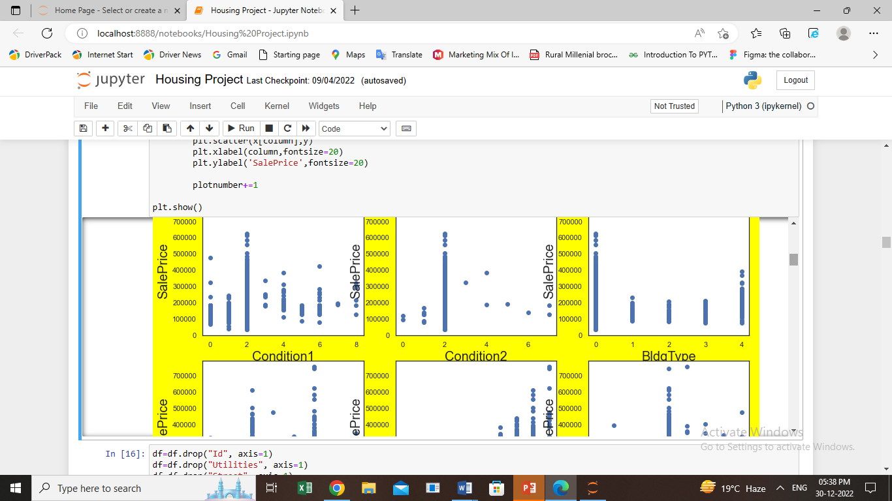

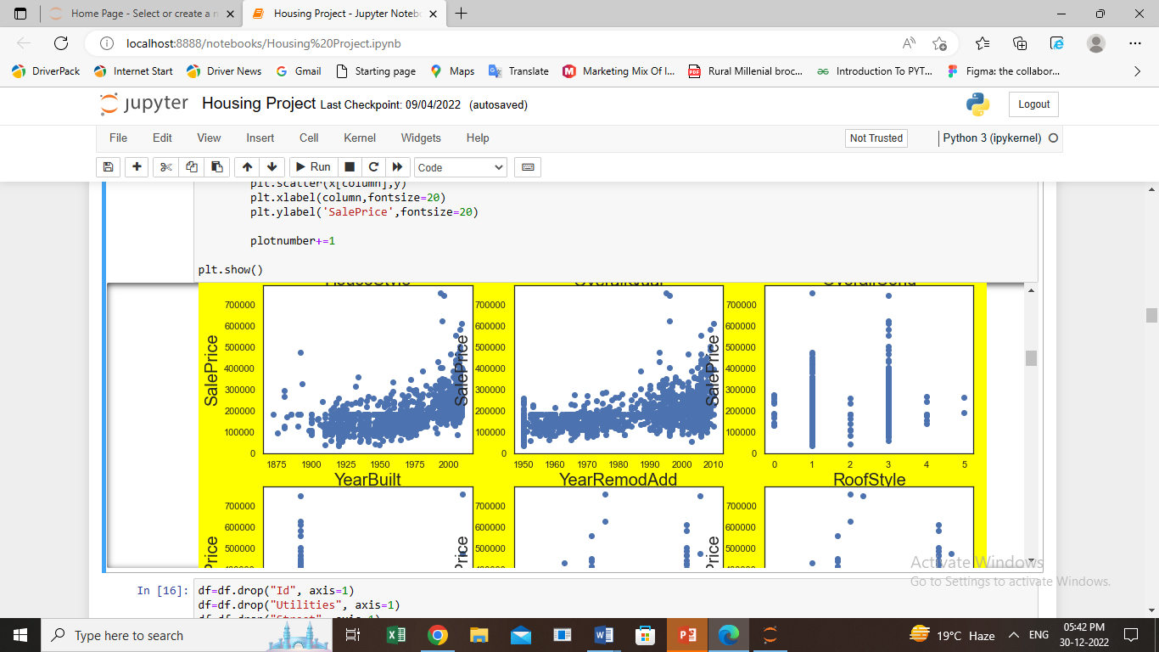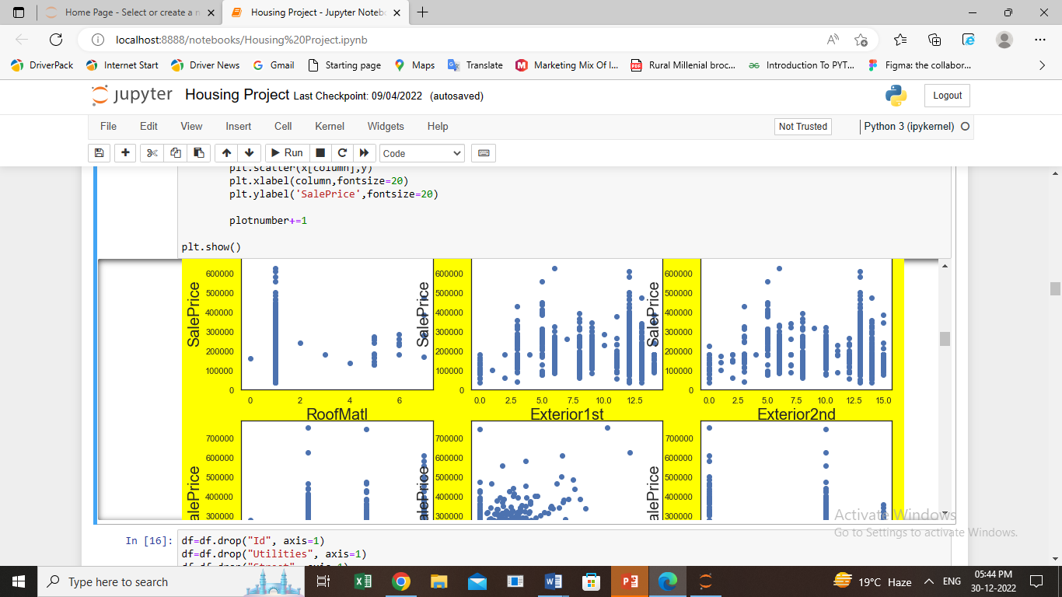 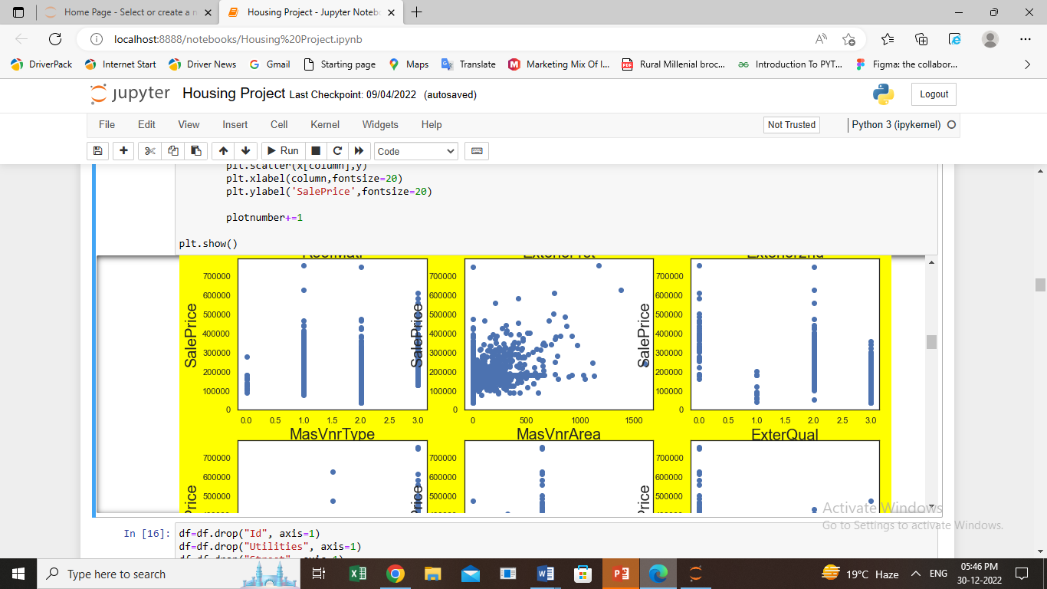 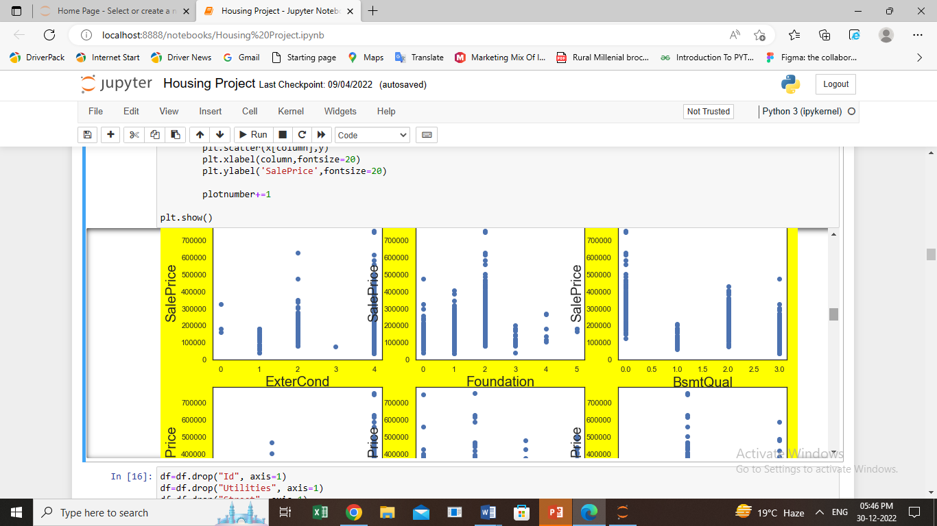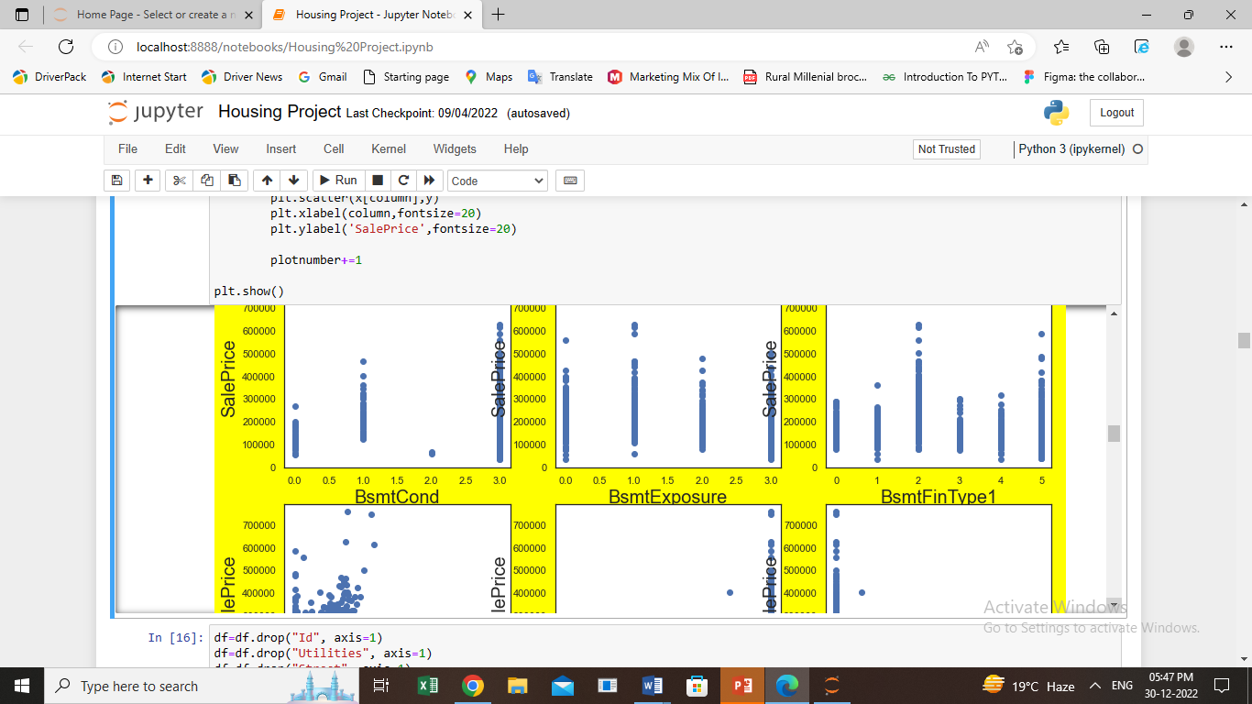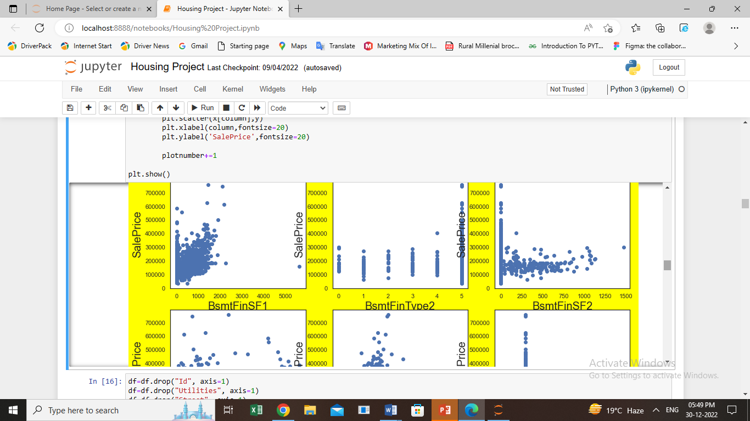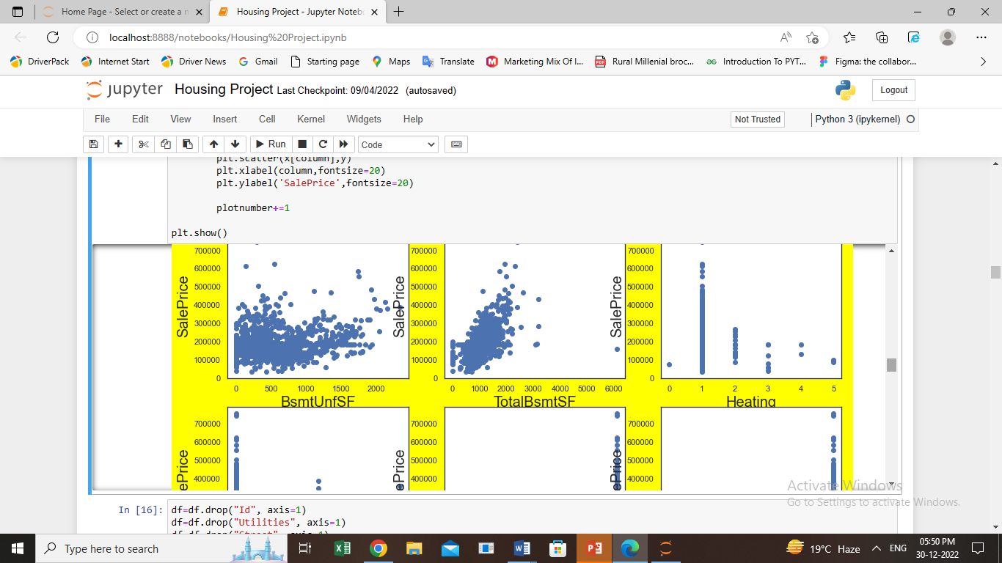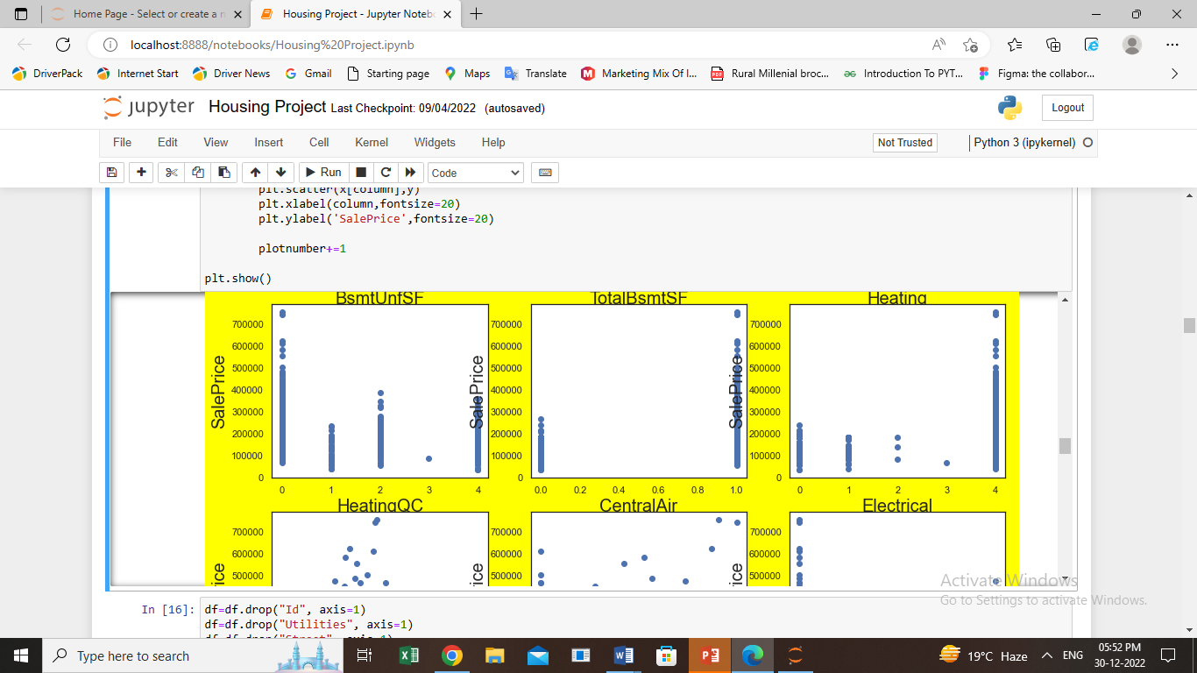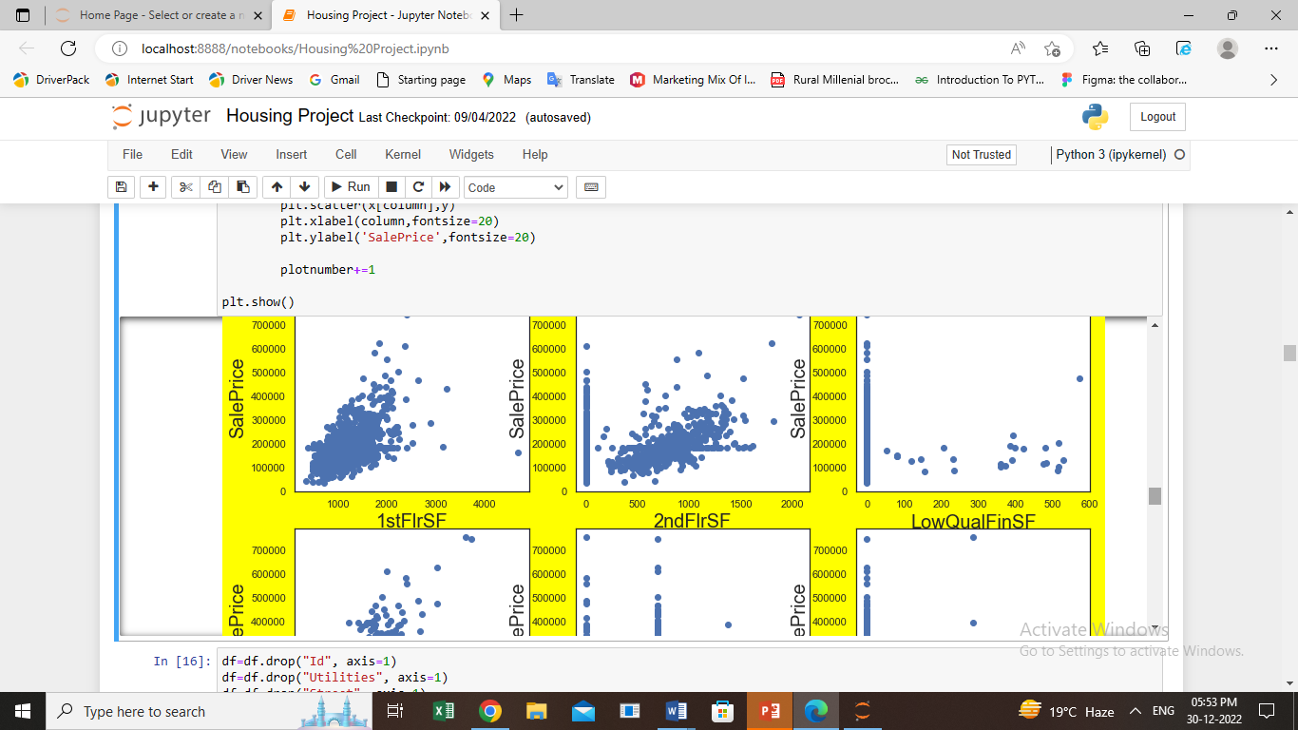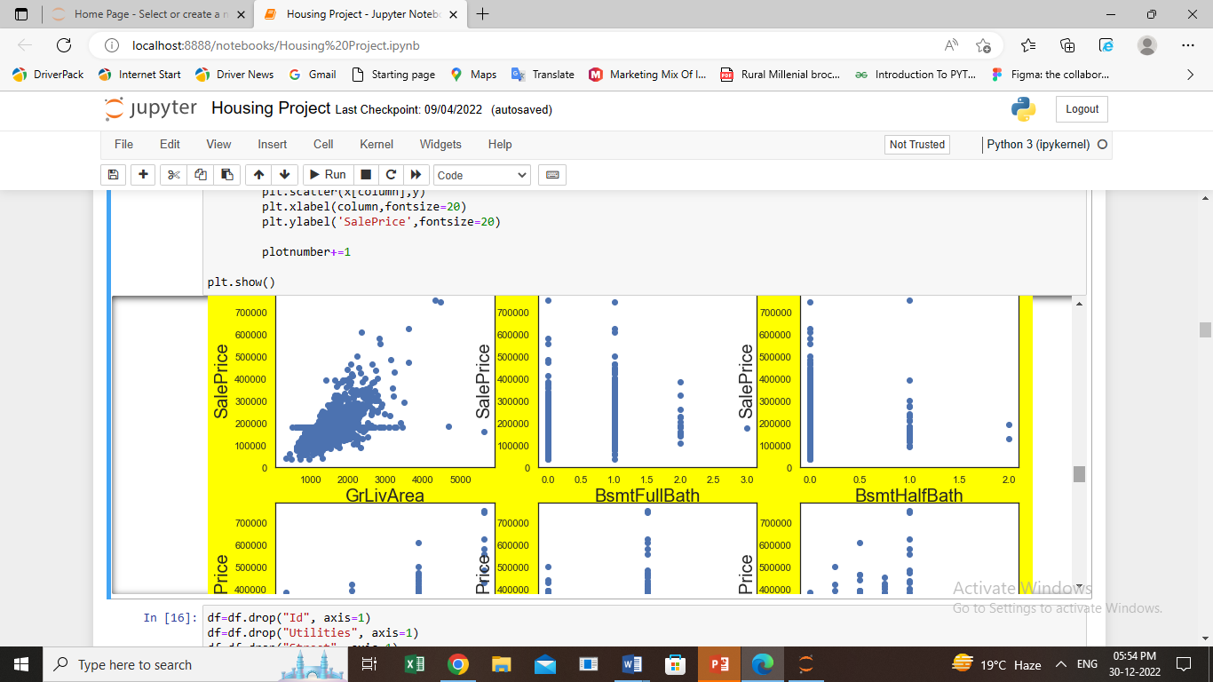

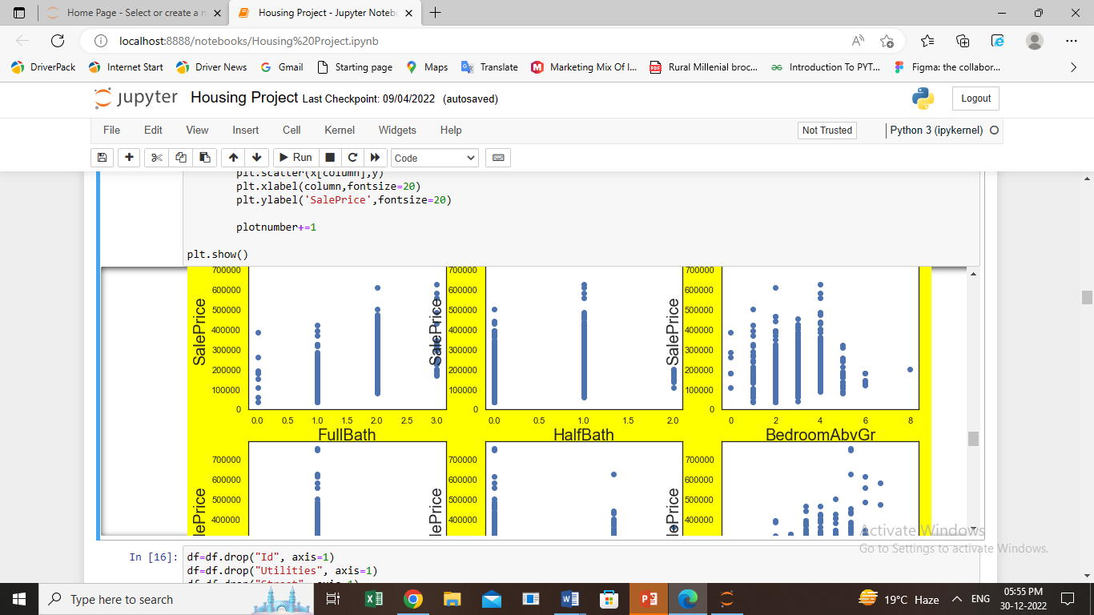

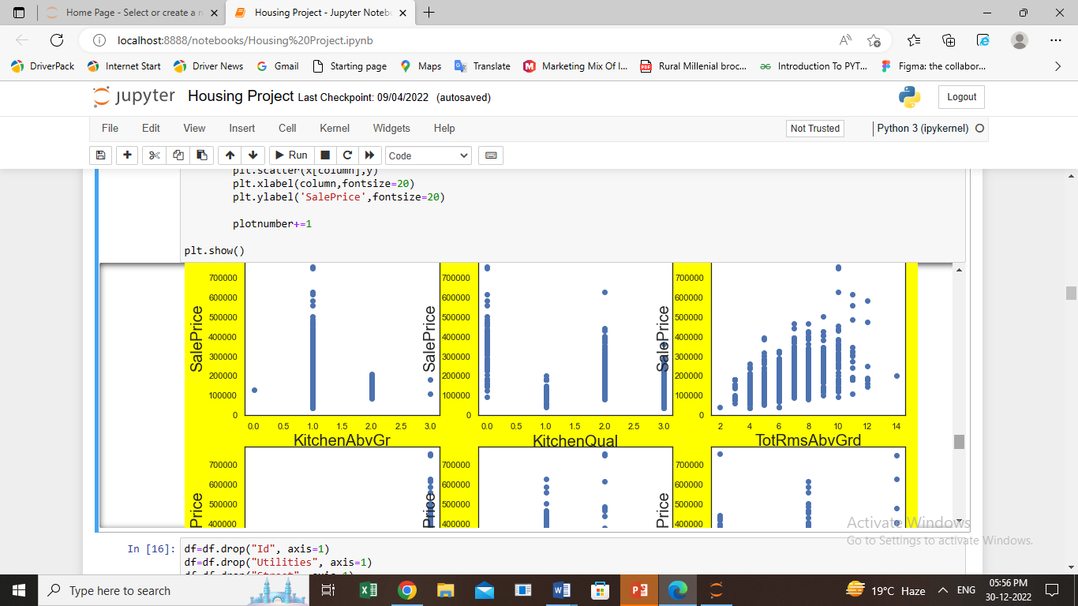

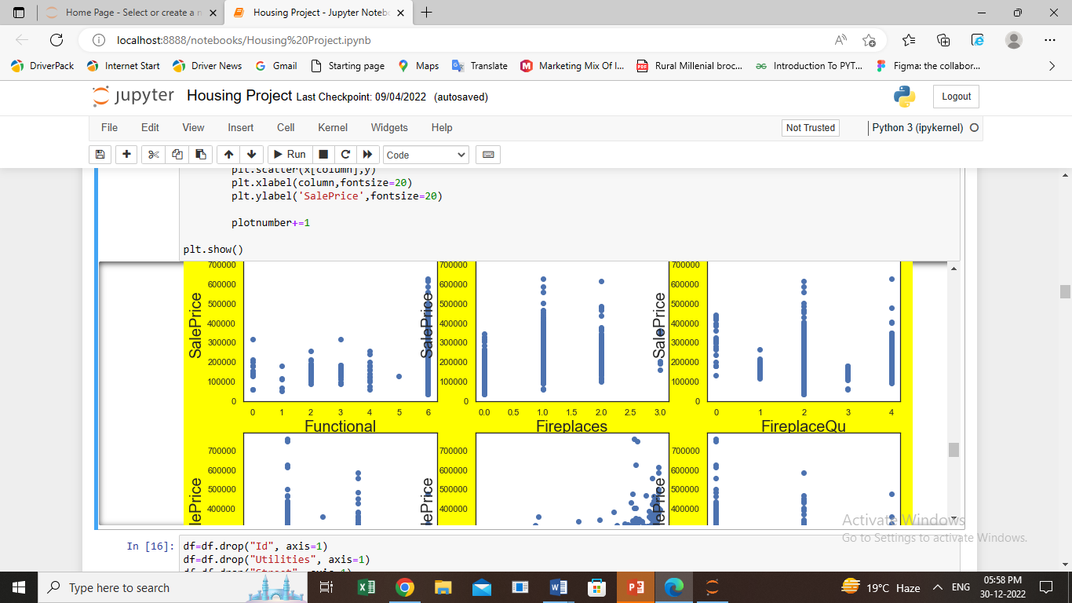

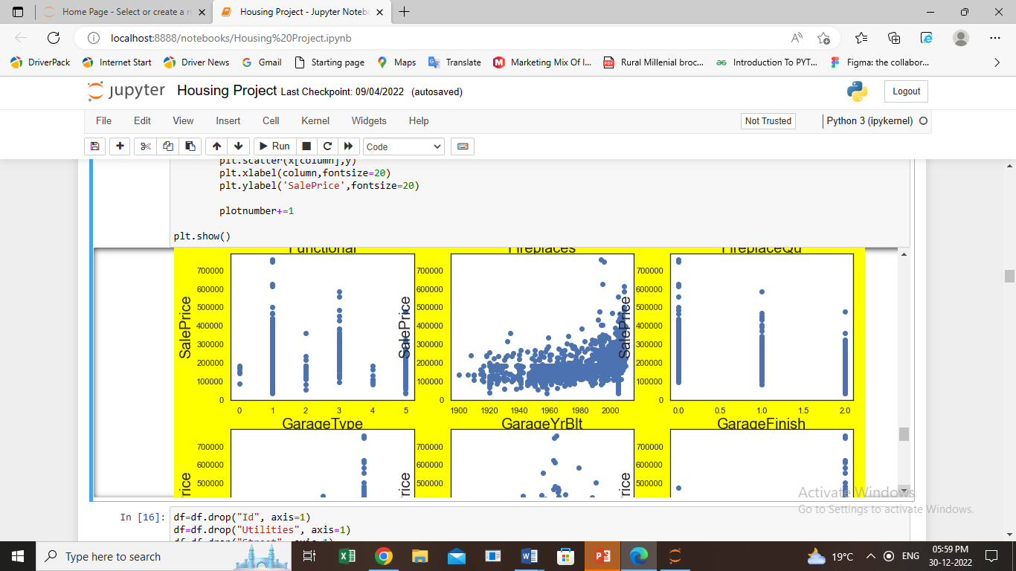

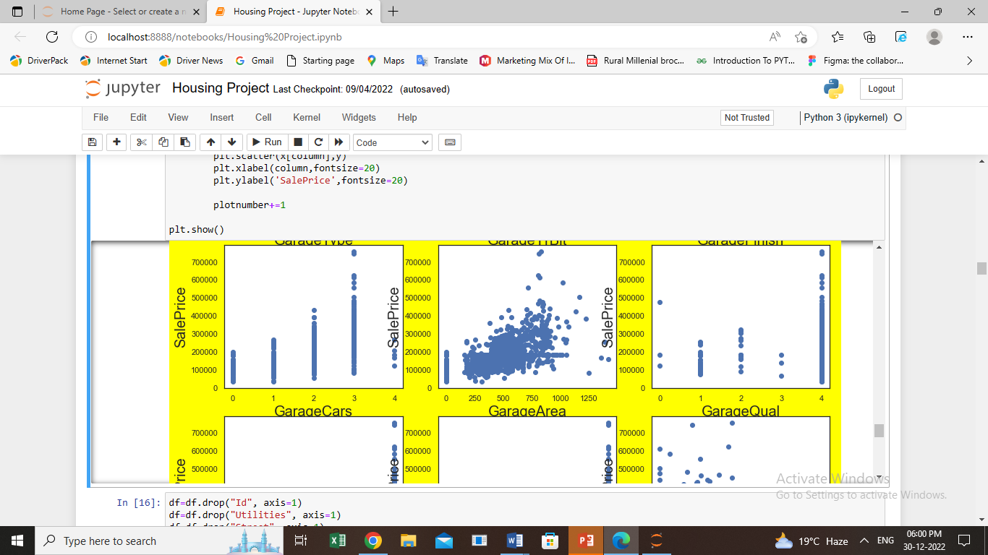

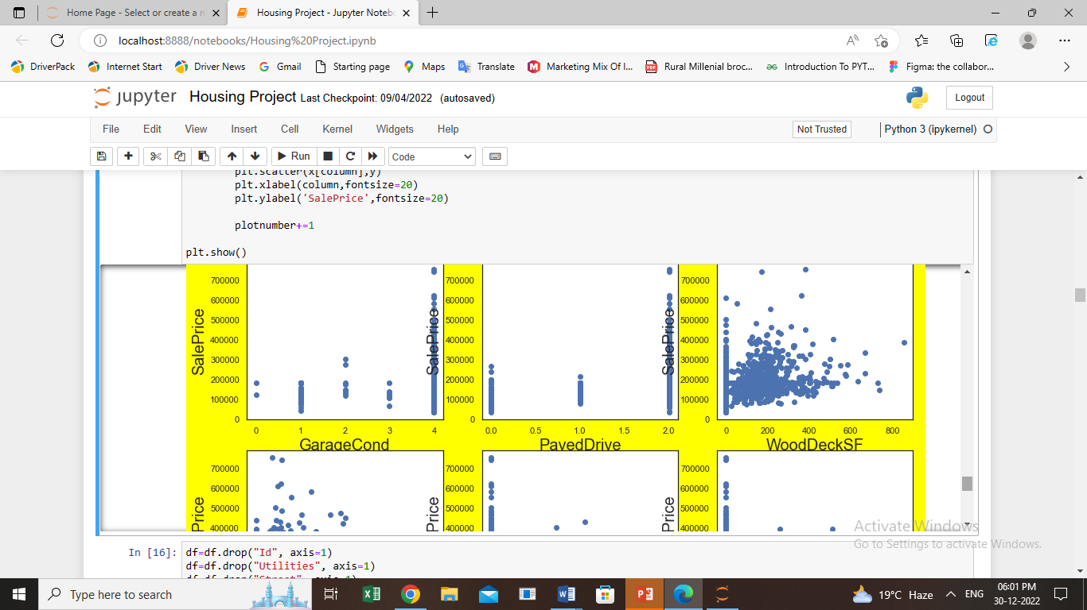

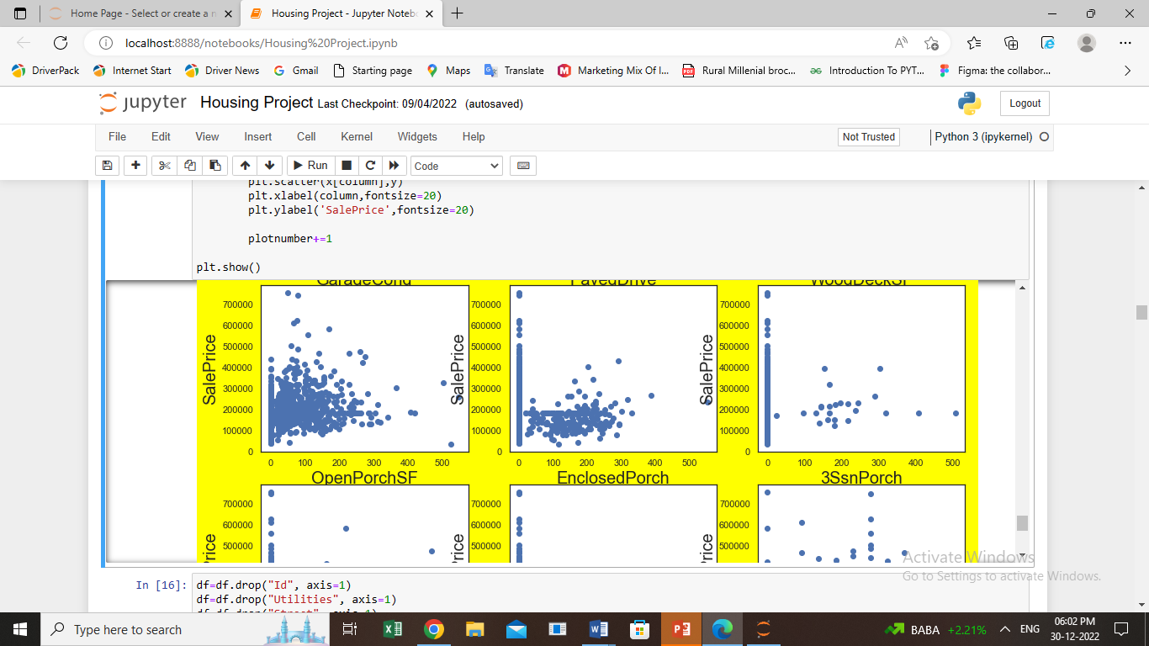

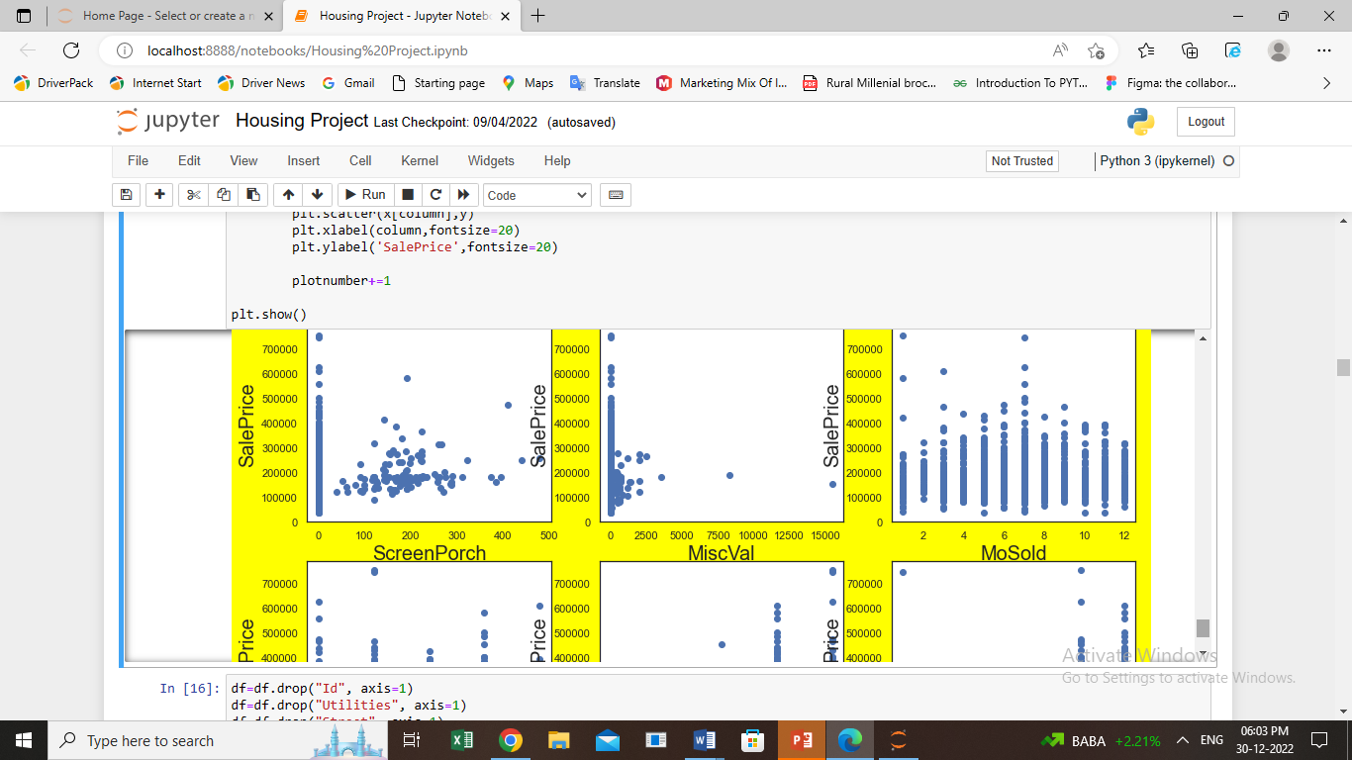

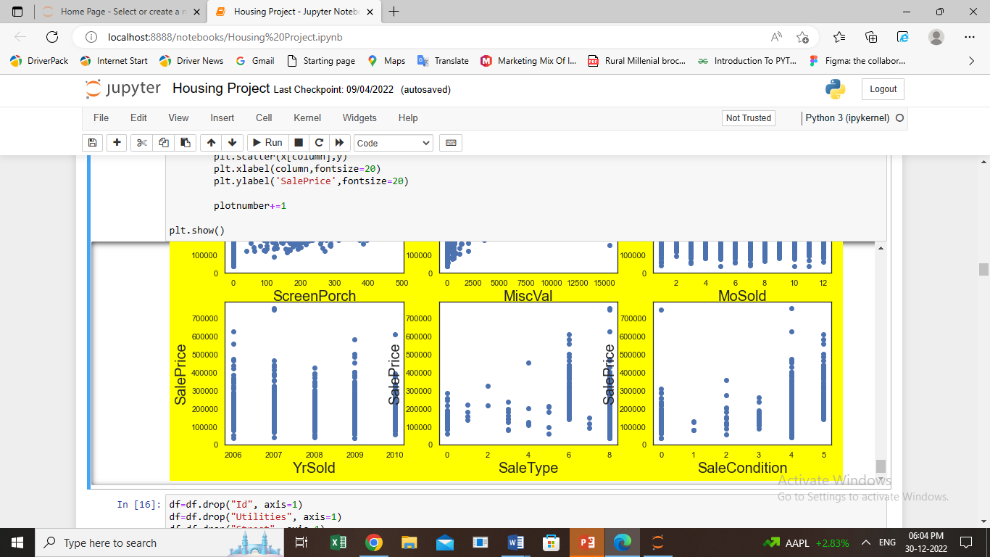

* df= df.drop("Id", axis=1)
* df= df.drop("Utilities", axis=1)
* df= df.drop("Street", axis=1)
* df= df.drop("PoolArea", axis=1)
* Let’s see how data is distributed.

plt**.**figure (figsize**=** (20,50),facecolor**=**'yellow')

plot number **=**1

**for** column **in** x:

**if** plotnumber**<=**35:

ax**=**plt**.**subplot(12,3,plotnumber)

sns**.**distplot(x[column])

plt**.**xlabel(column,fontsize**=**20)

plt**.**ylabel('Attrition',fontsize**=**20)

plotnumber**+=**1

plt**.**show()

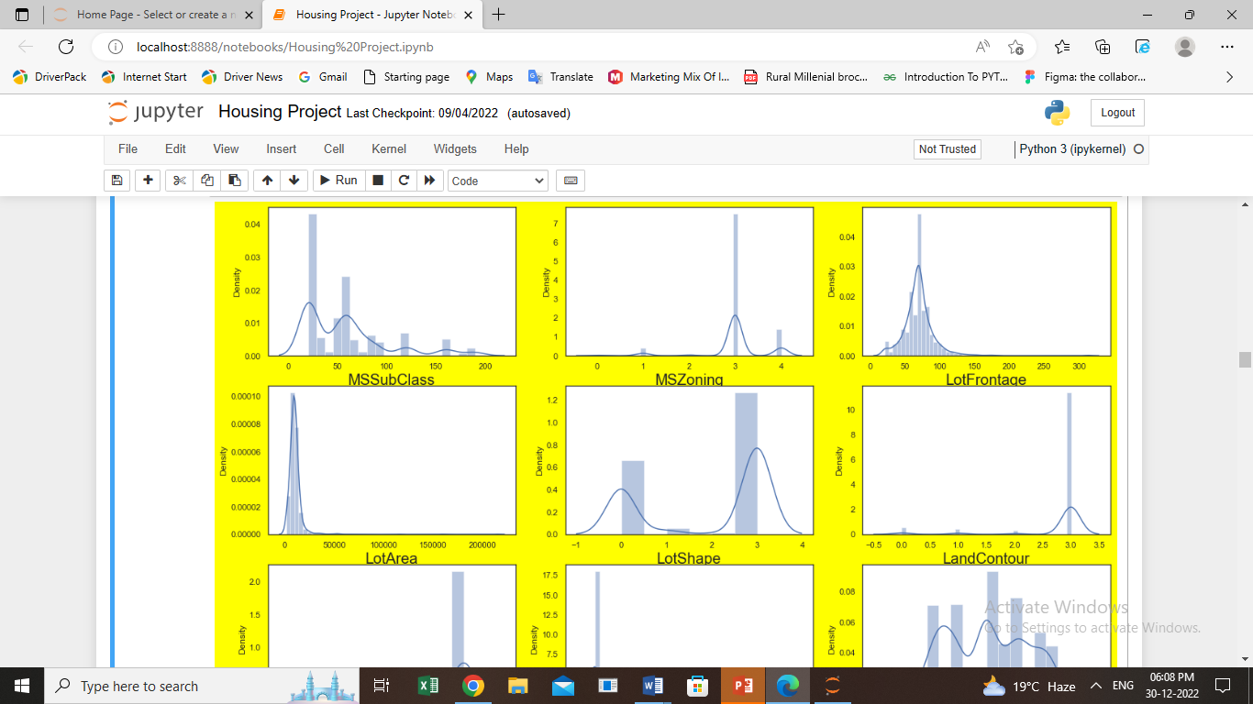

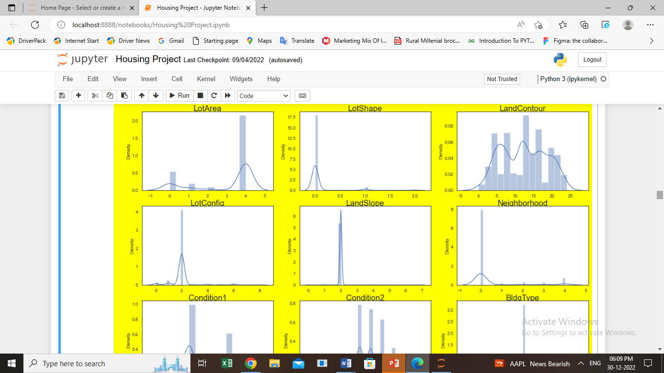

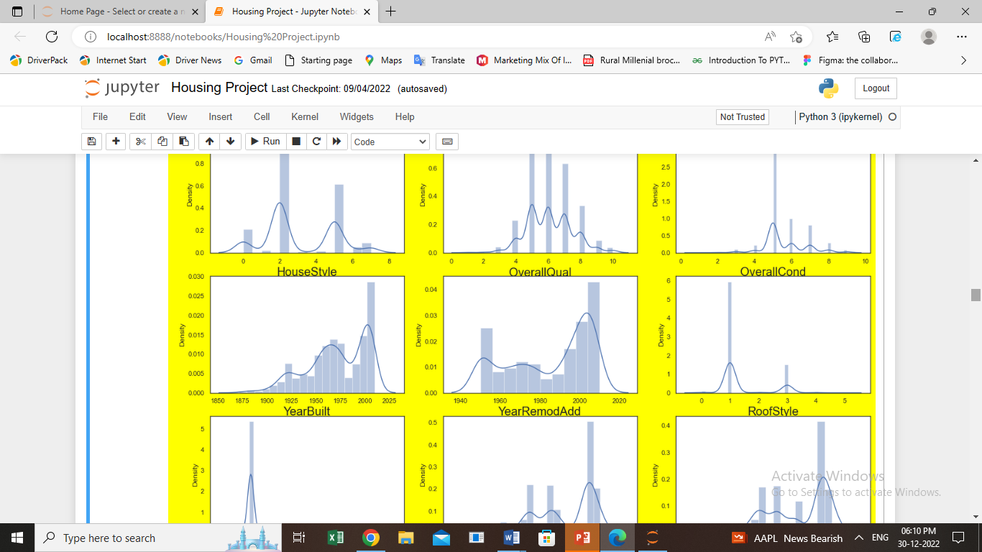

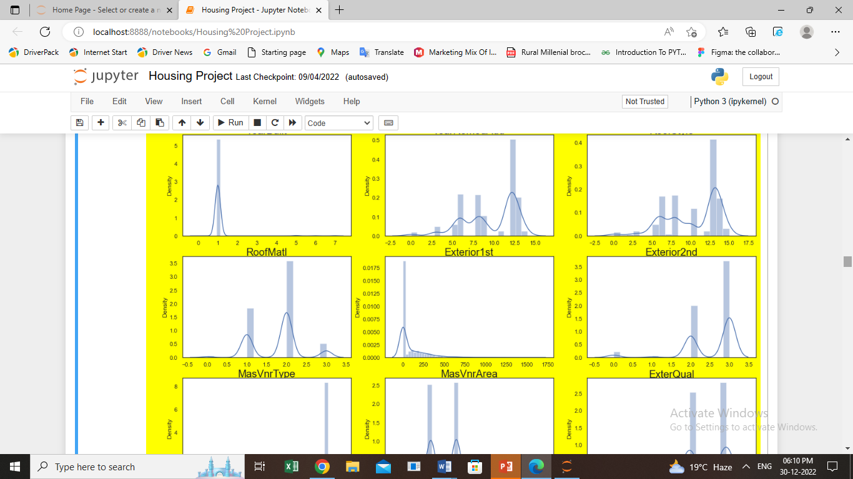

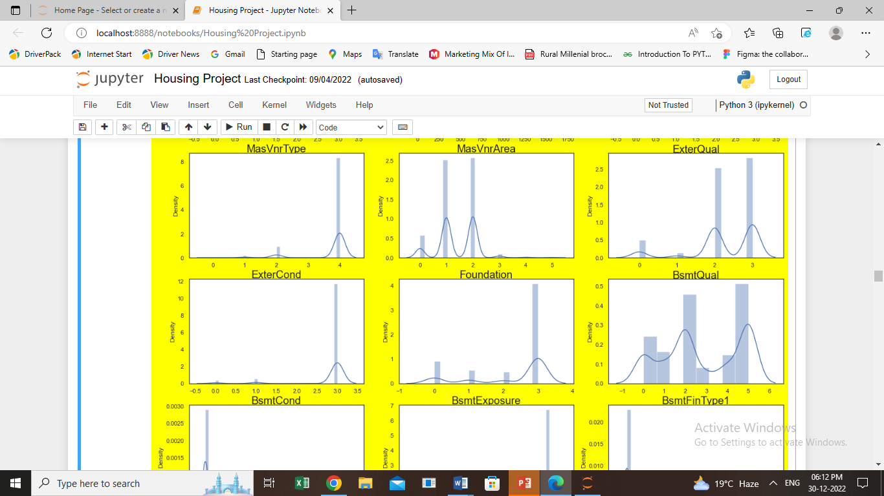

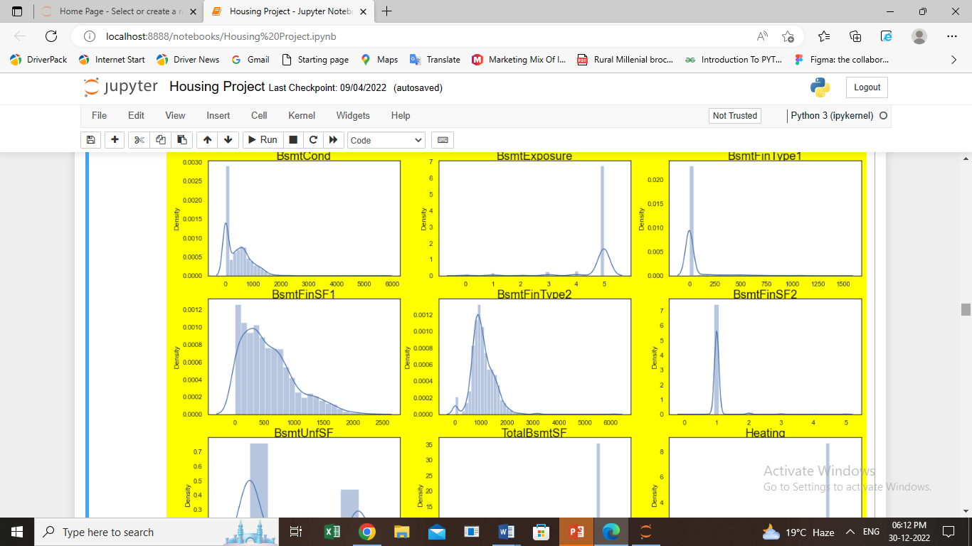

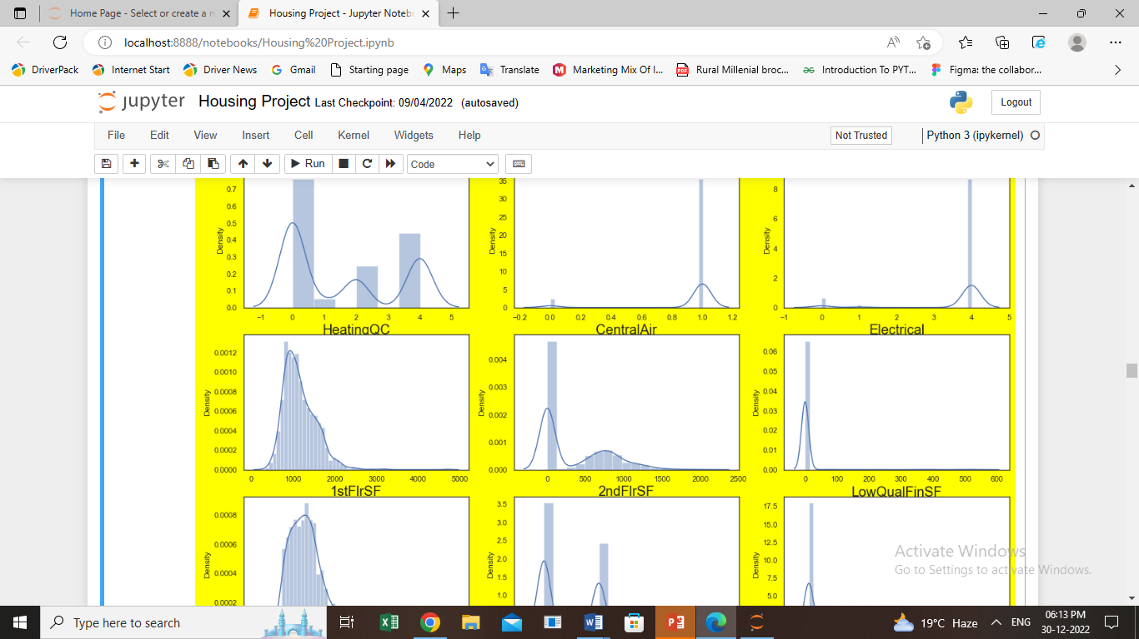

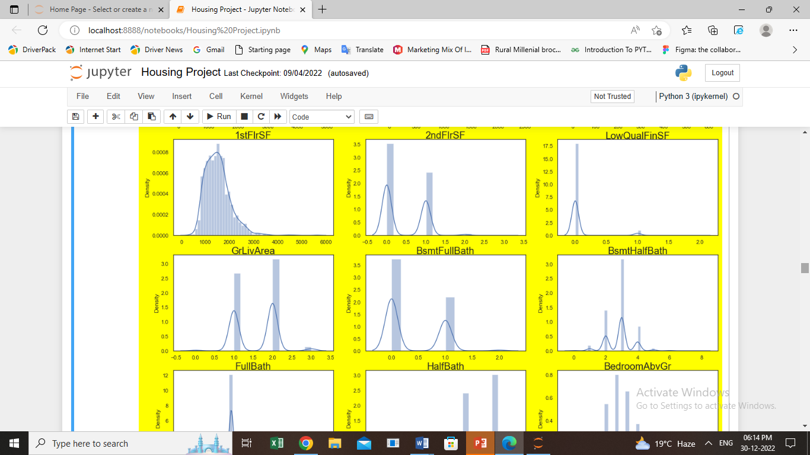

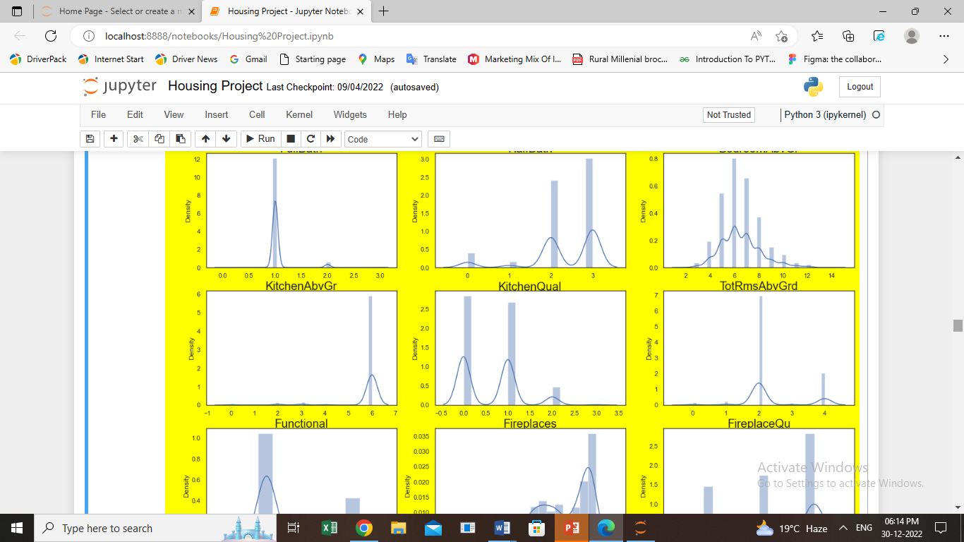

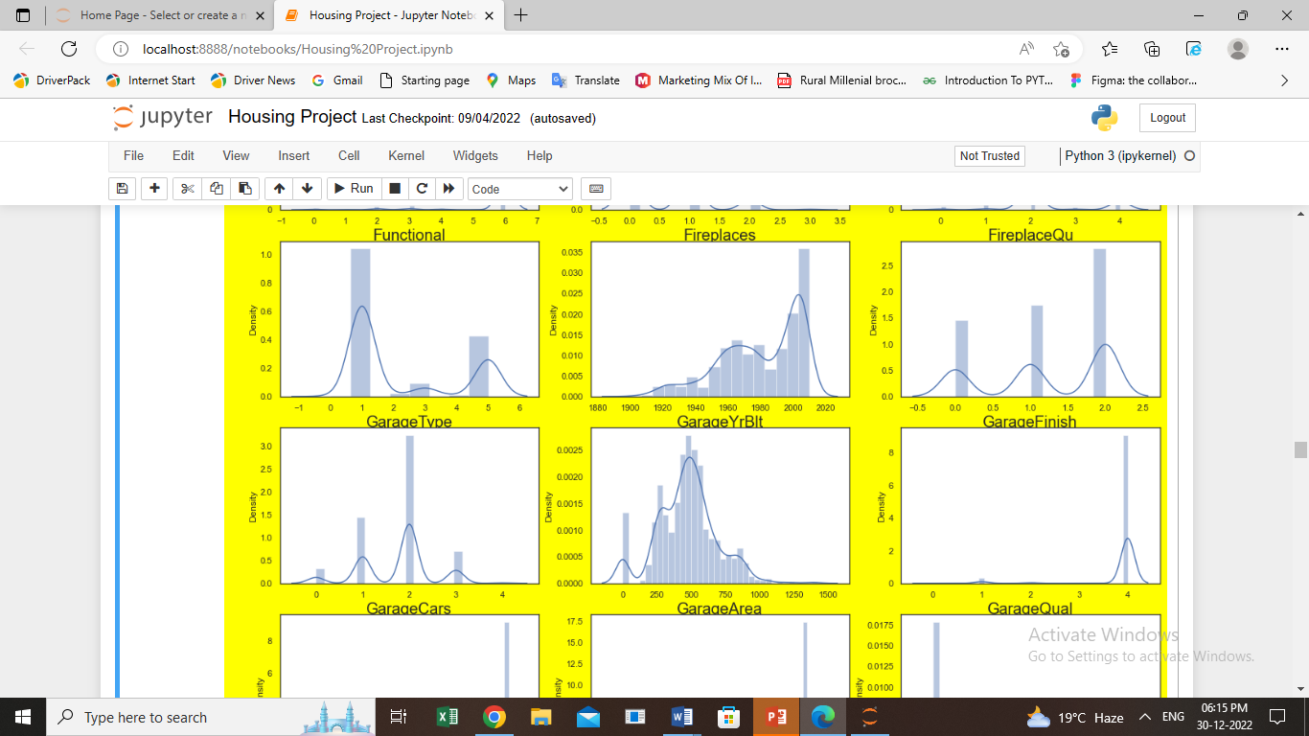

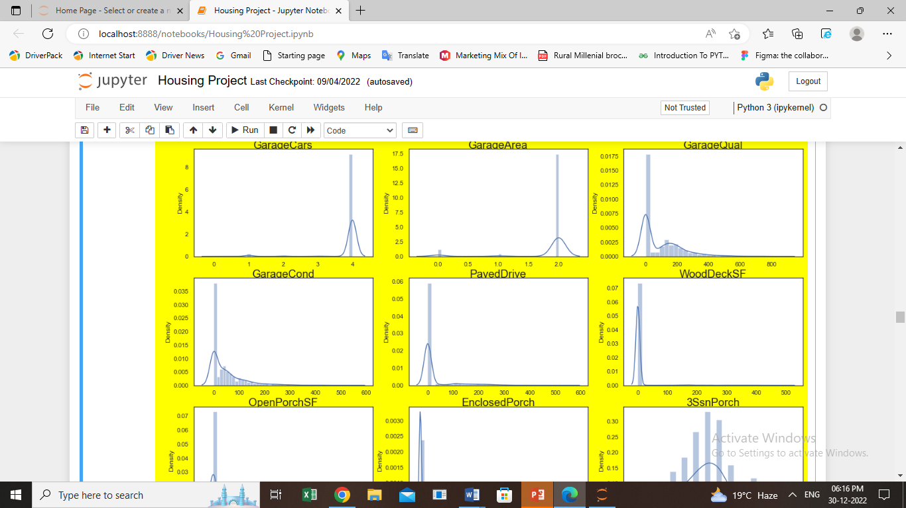

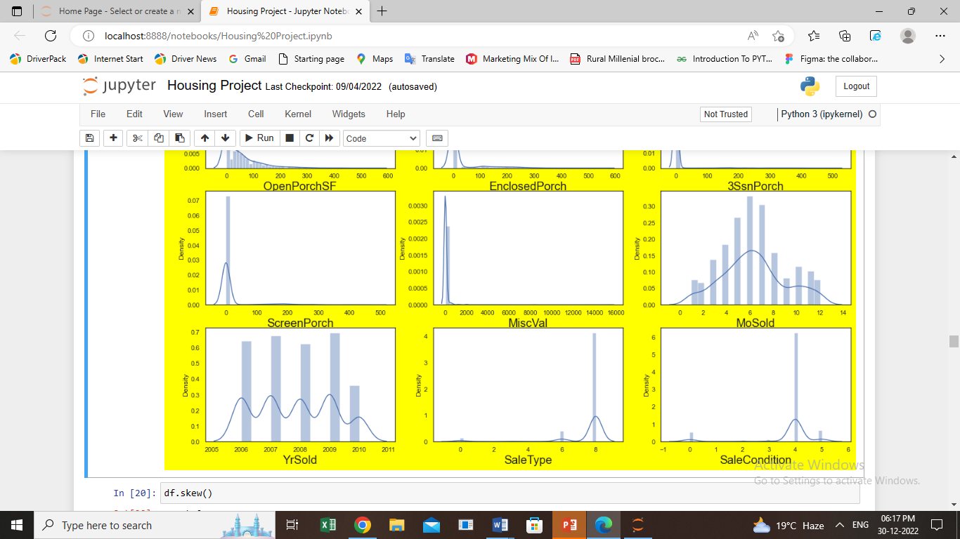

* There are many skewness in different columns like in BusinessTravel, DistanceFromHome, JobLevel, MonthlyIncome, NumCompaniesWorked, OverTime, PercentSalaryHike,PerformanceRating,StockOptionLevel, TotalWorkingYears, YearsInCurrentRole, YearsSinceLastPromotion, YearsWithCurrManager.
* Let’s treat skewness of required columns with continous data.
* df['DistanceFromHome']**=**np**.**sqrt(df['DistanceFromHome'])
* df['PercentSalaryHike']**=**np**.**sqrt(df['PercentSalaryHike'])
* df['TotalWorkingYears']**=**np**.**sqrt(df['TotalWorkingYears'])
* df['YearsInCurrentRole']**=**np**.**sqrt(df['YearsInCurrentRole'])
* df['YearsSinceLastPromotion']**=**np**.**sqrt(df['YearsSinceLastPromotion'])
* df['YearsWithCurrManager']**=**np**.**sqrt(df['YearsWithCurrManager'])
* Let’s see how data is distributed and check outliers.

plt**.**figure(figsize**=**(20,50),facecolor**=**'yellow')

plotnumber**=**1

**for** column **in** x:

**if** plotnumber**<=**35:

ax**=**plt**.**subplot(12,3,plotnumber)

sns**.**boxplot(x[column])

plt**.**xlabel(column,fontsize**=**20)

plotnumber**+=**1

plt**.**show()

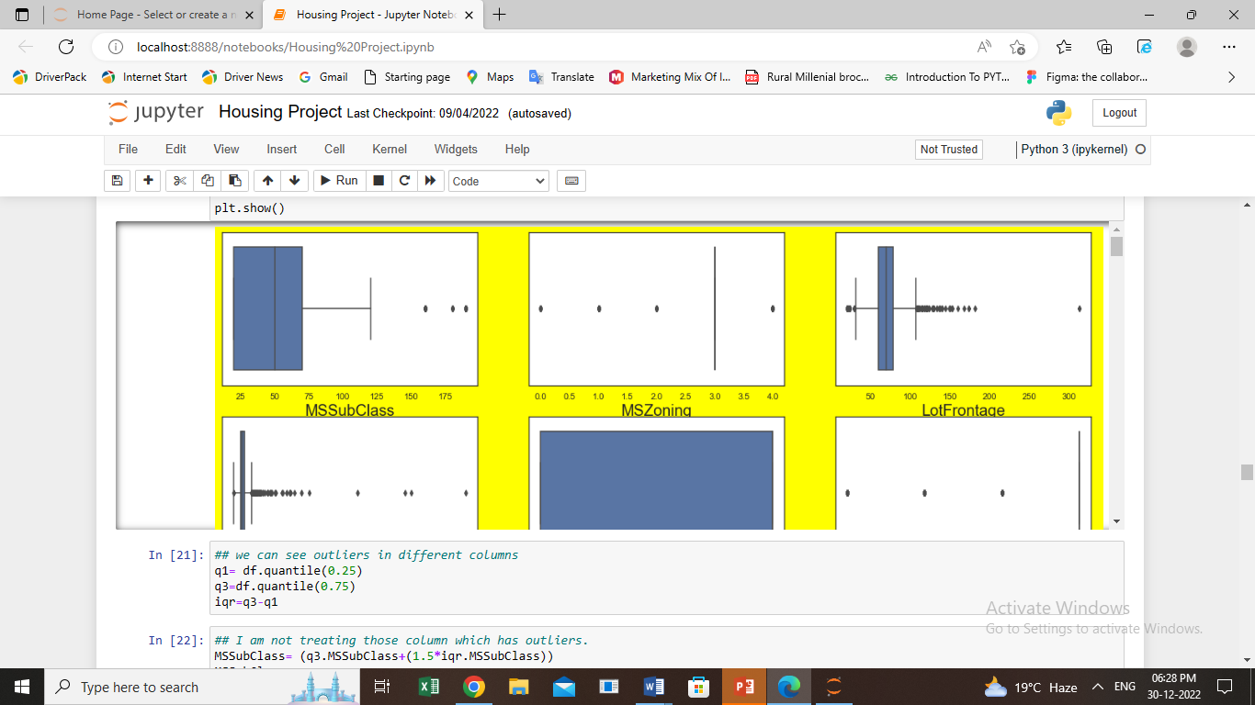

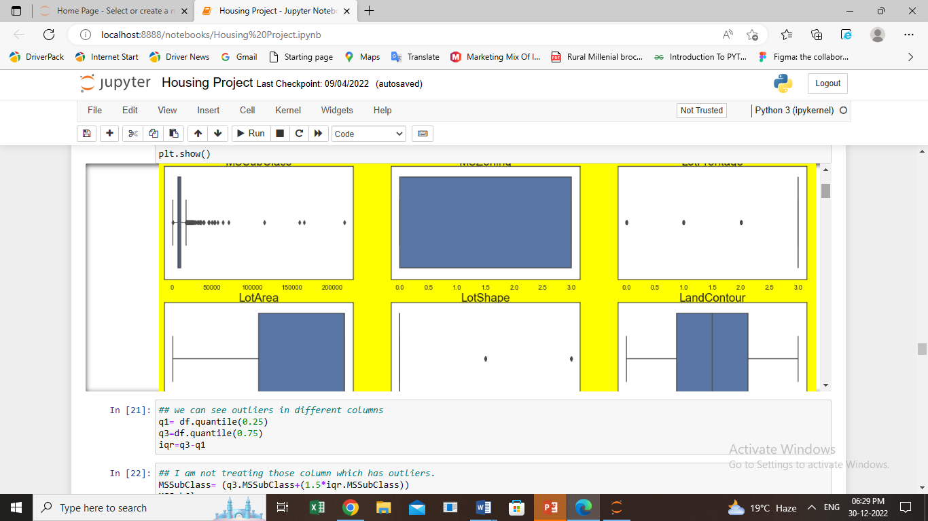

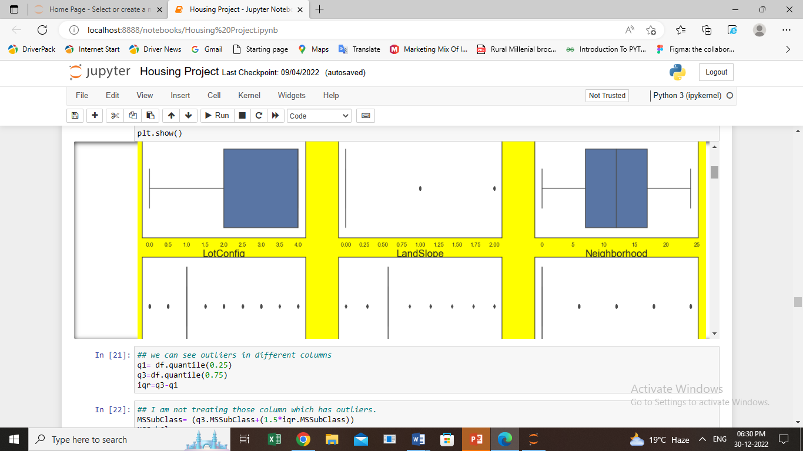

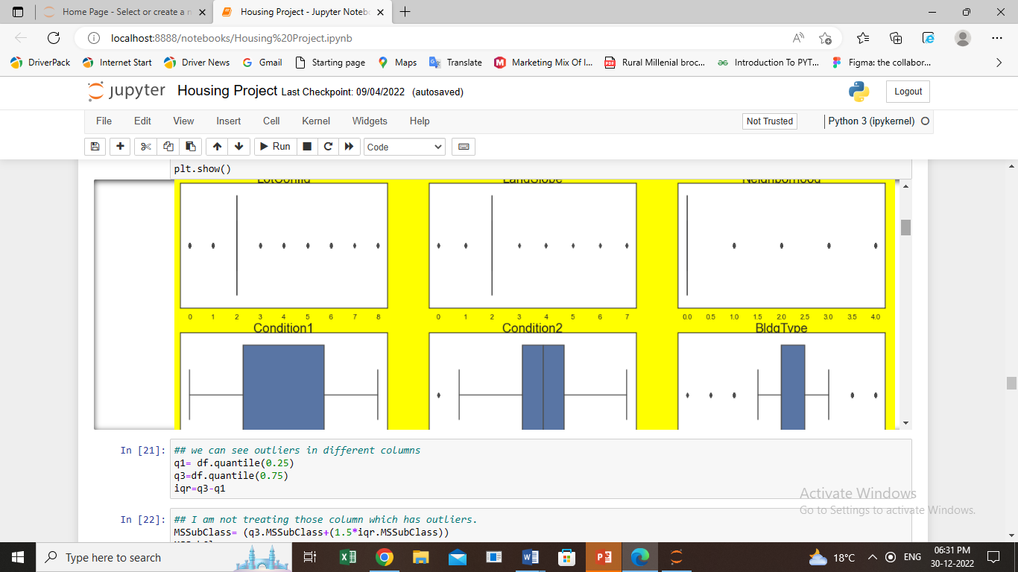

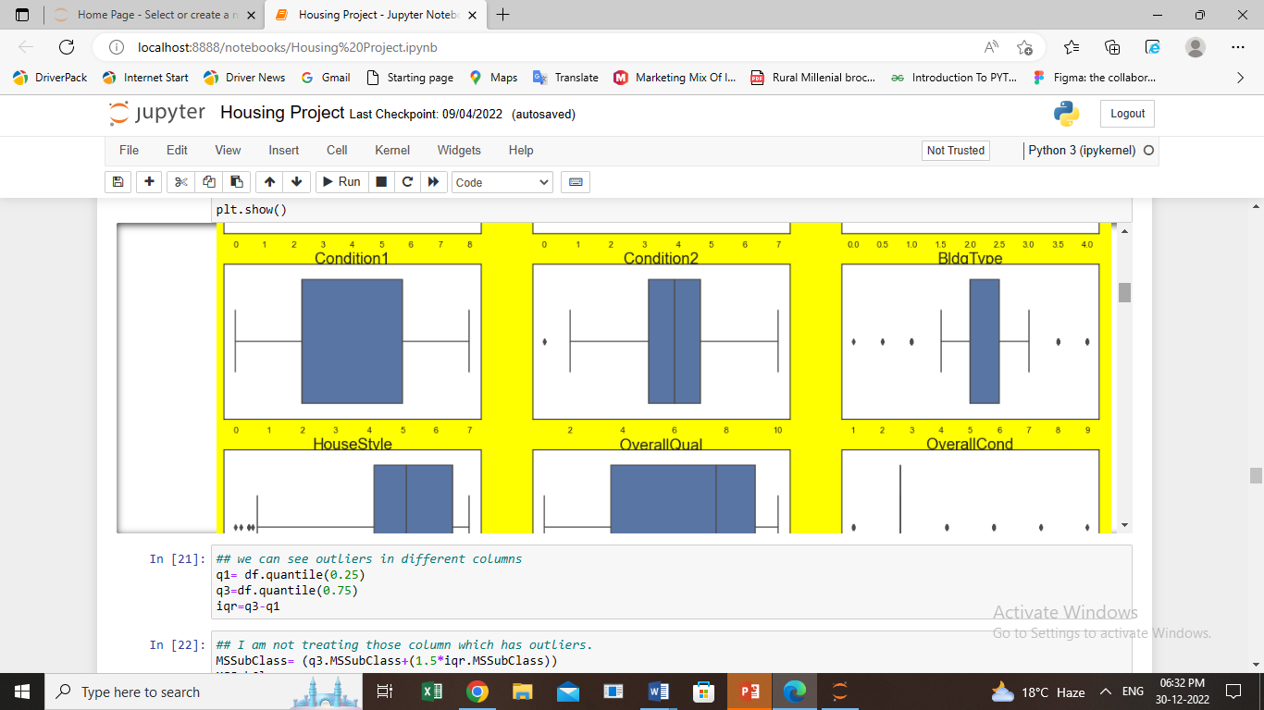

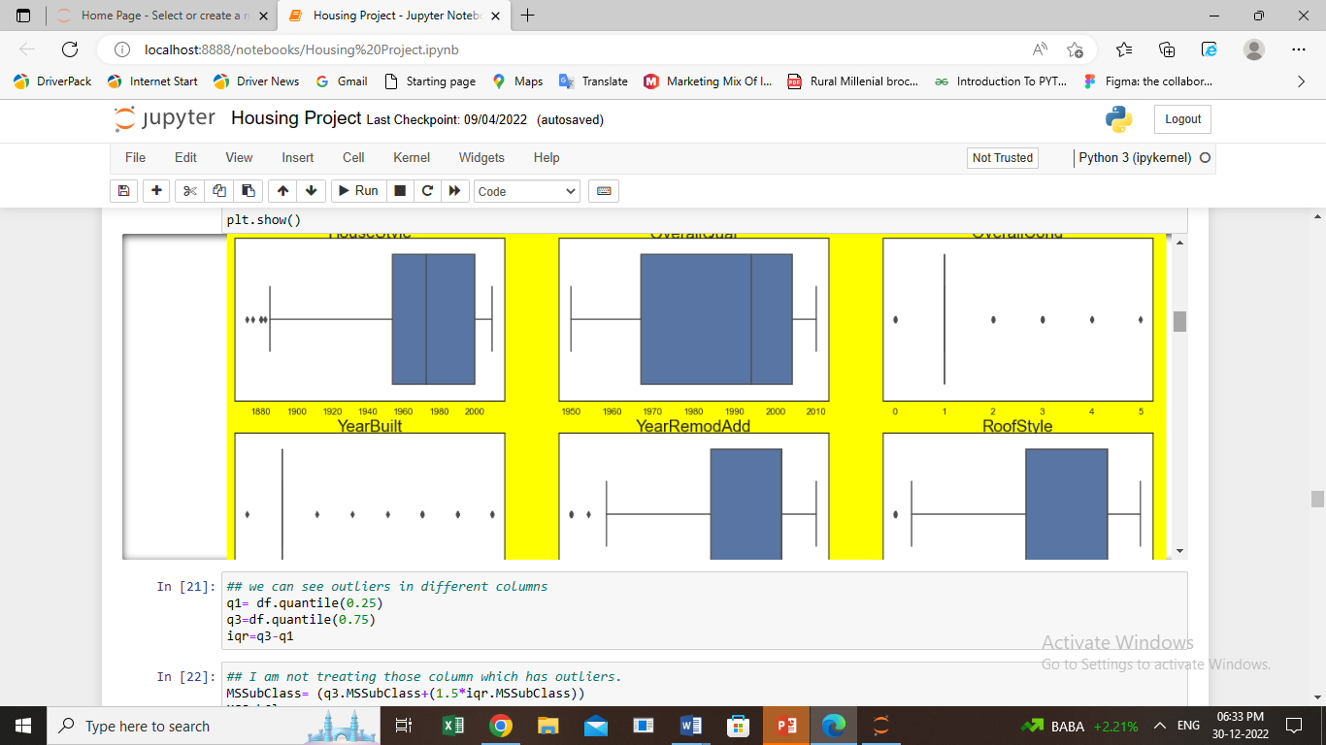

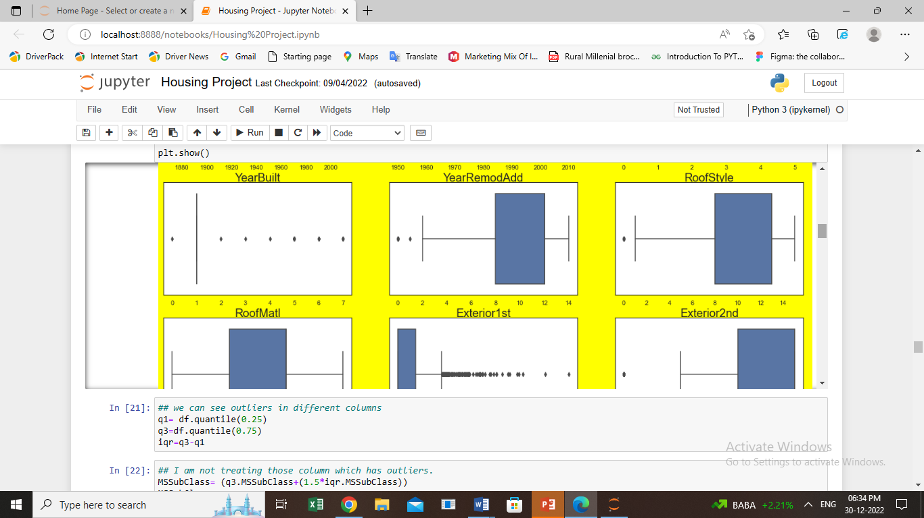

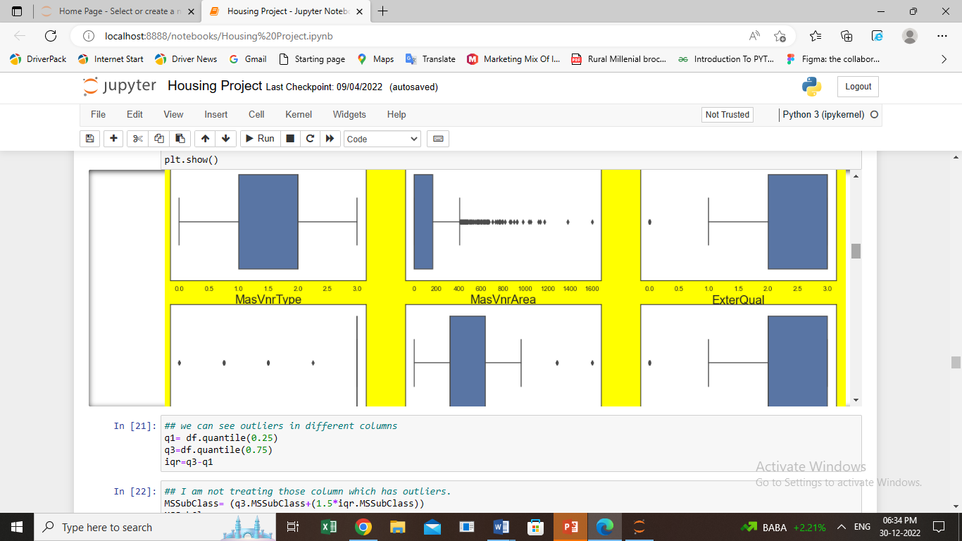

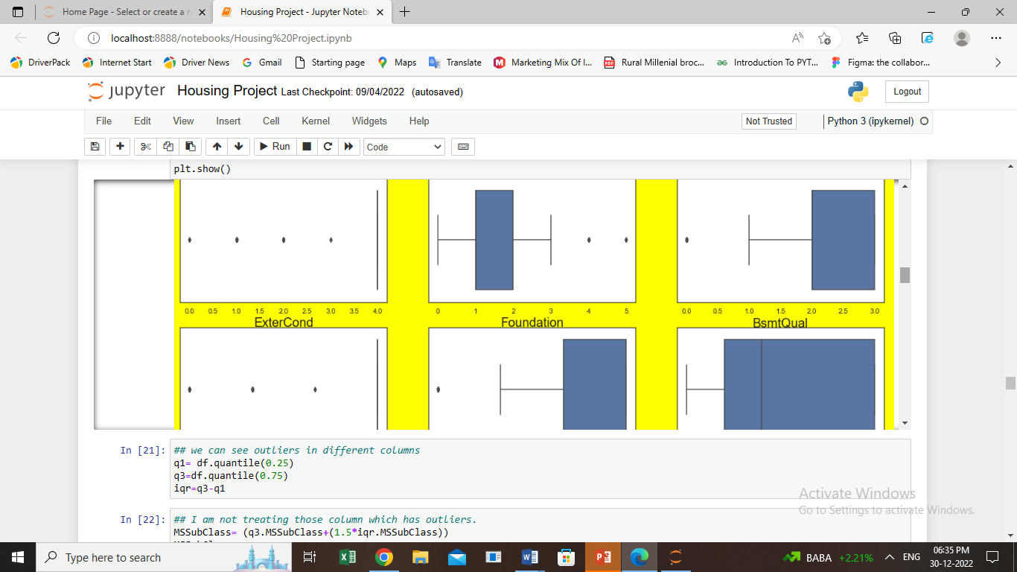

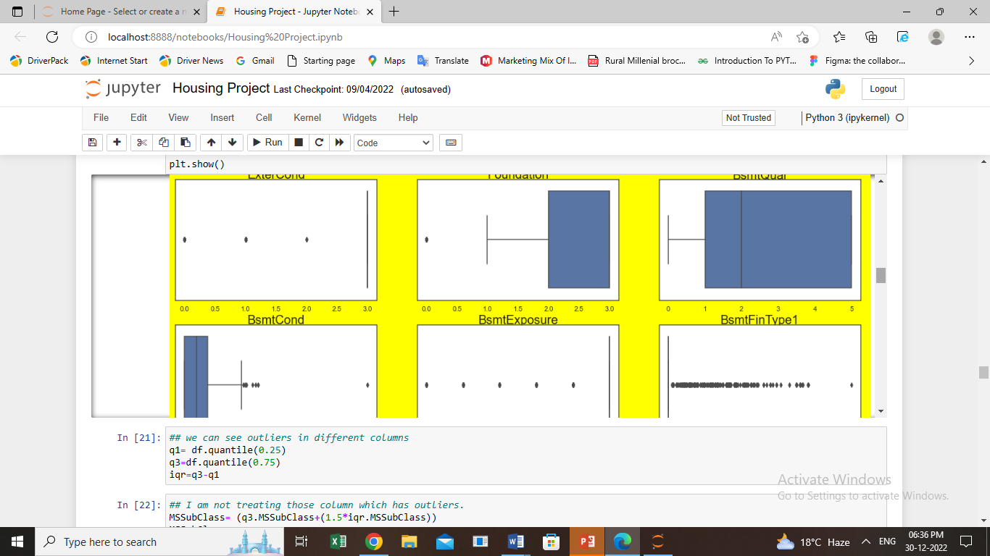

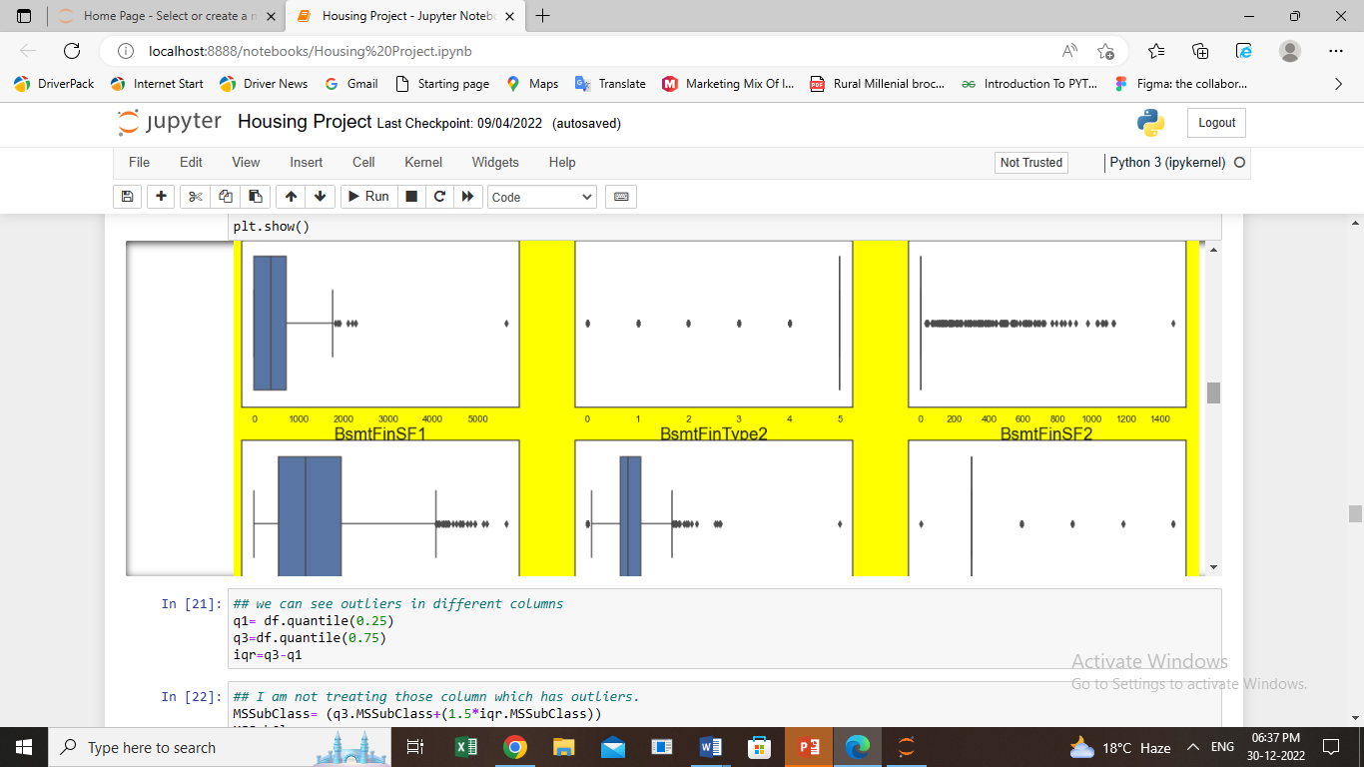

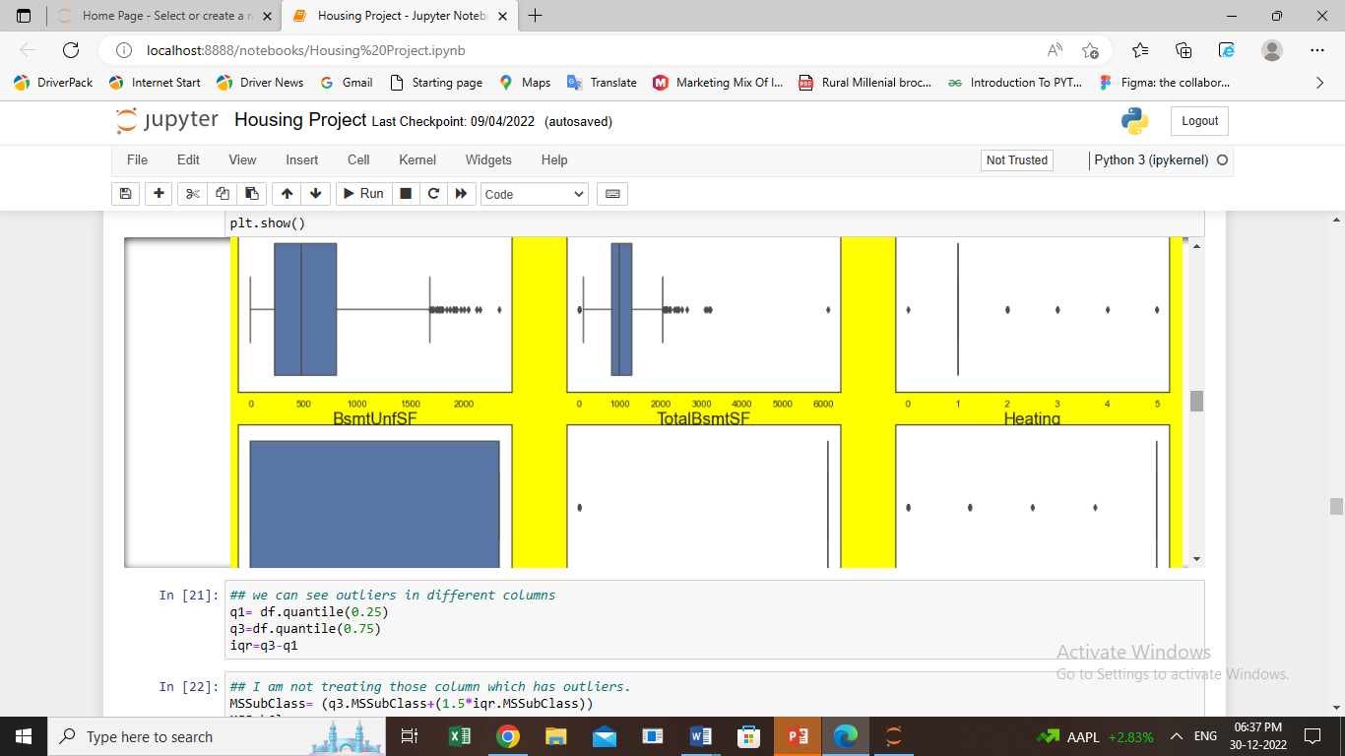

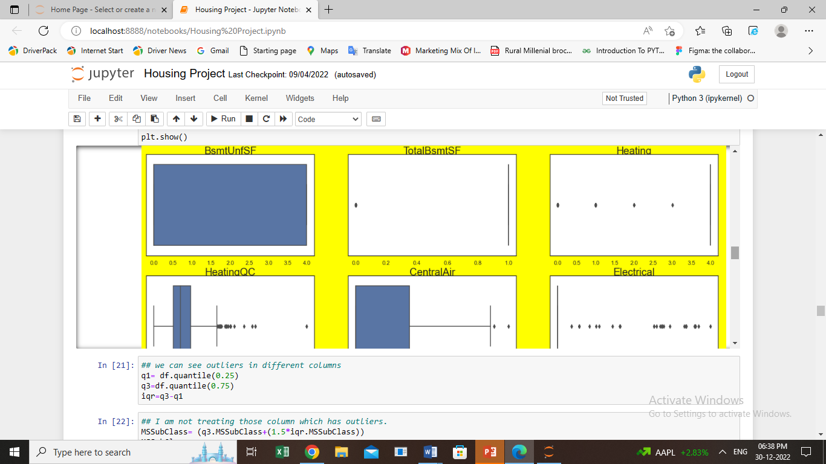

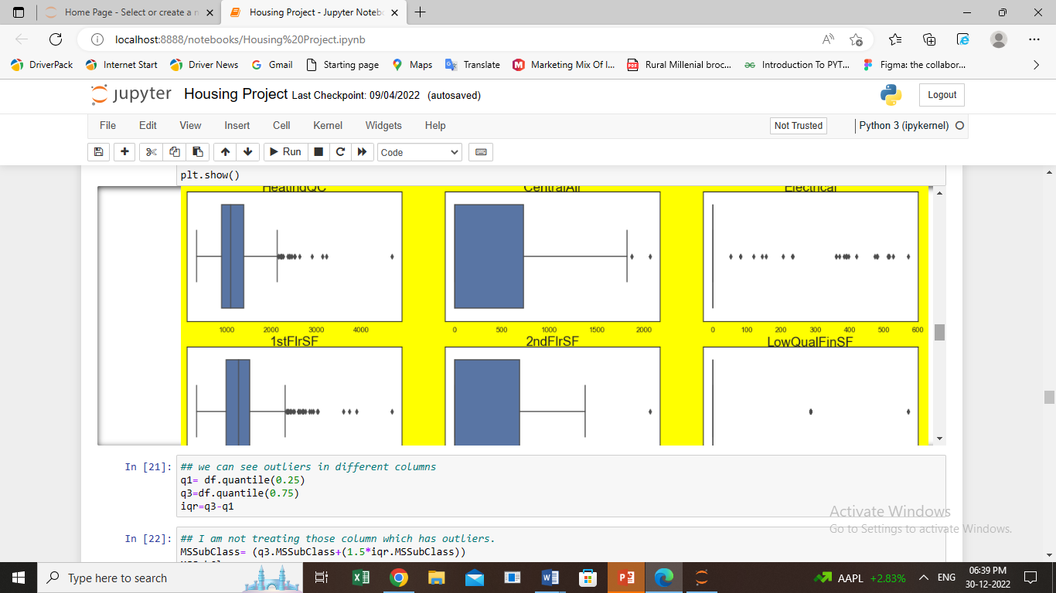

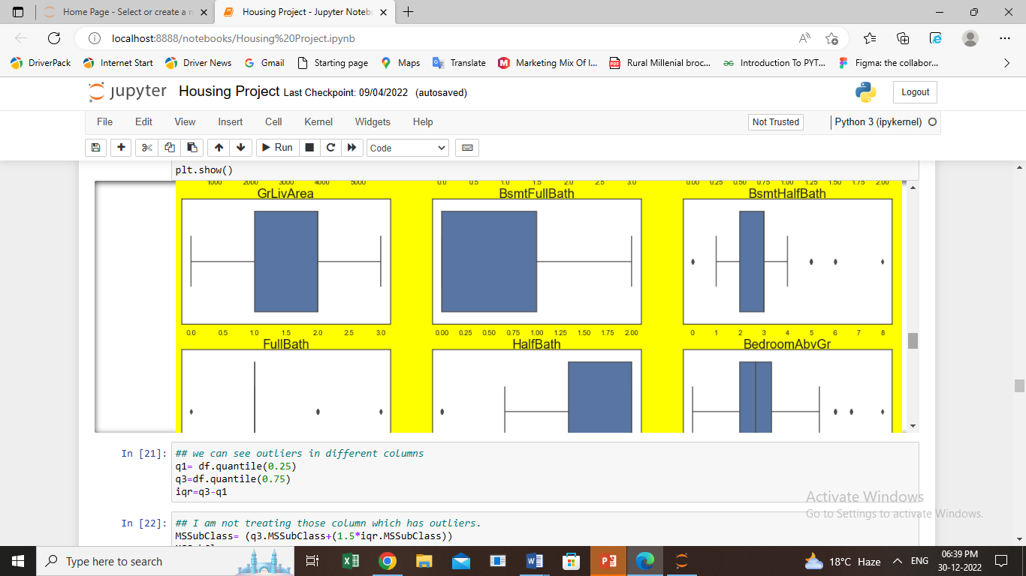

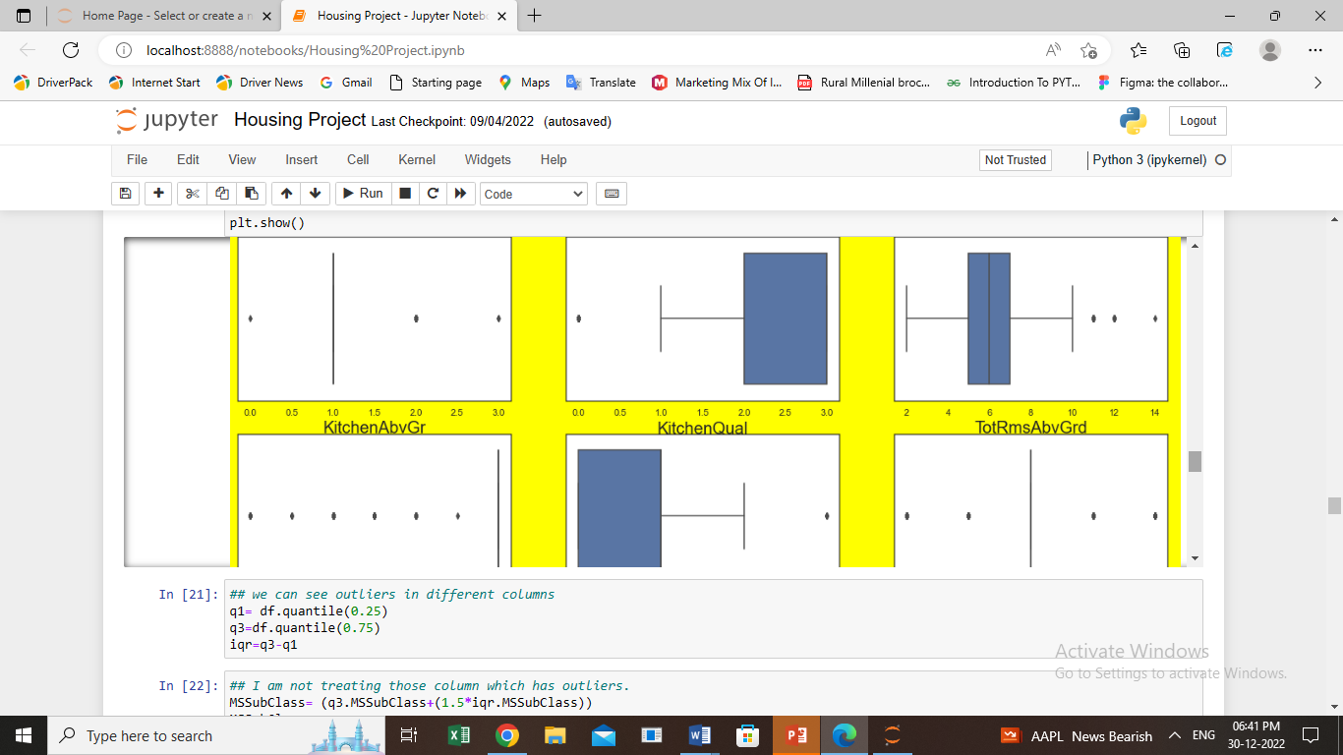

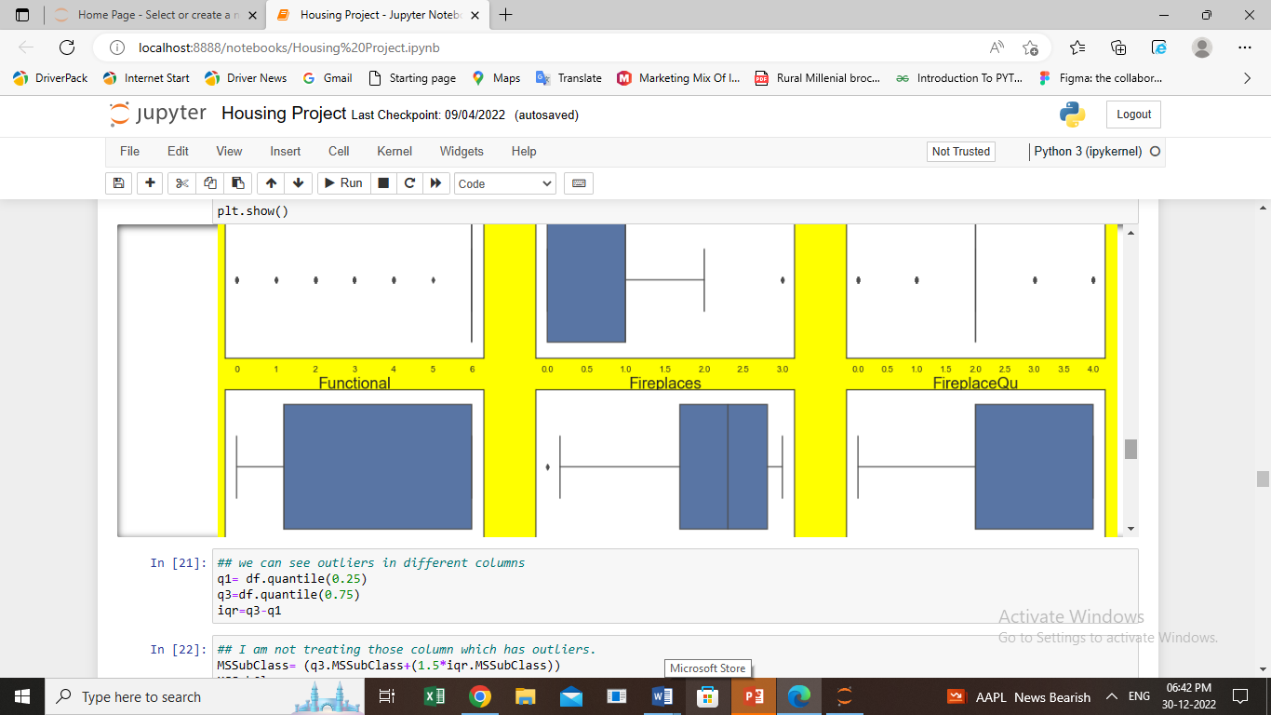

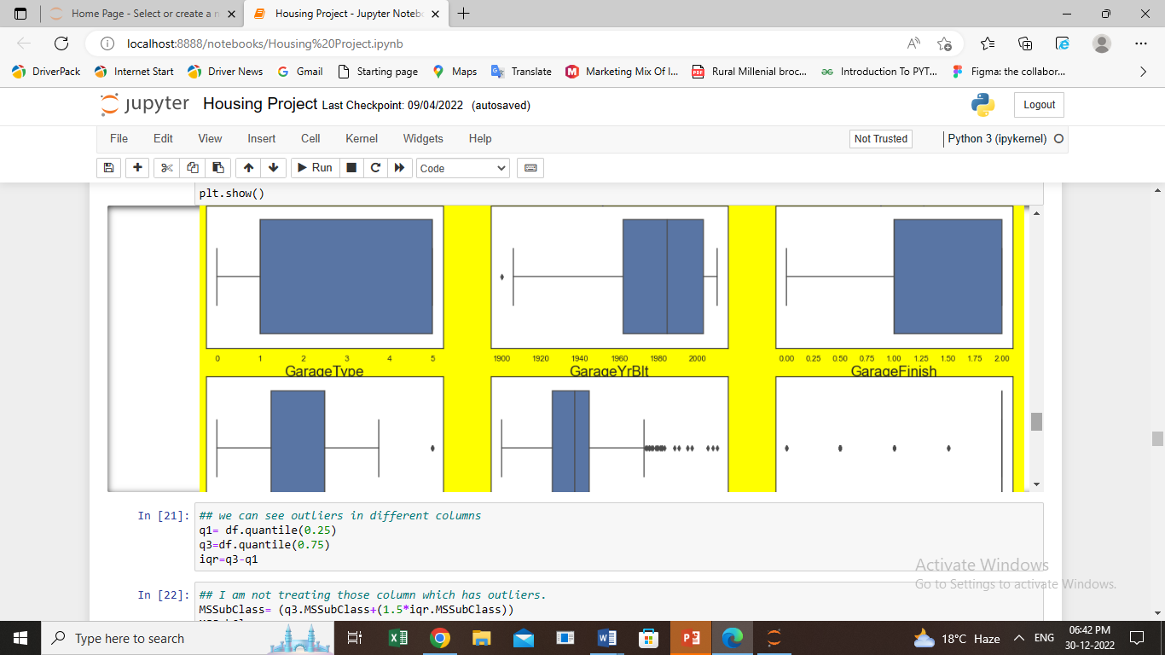

1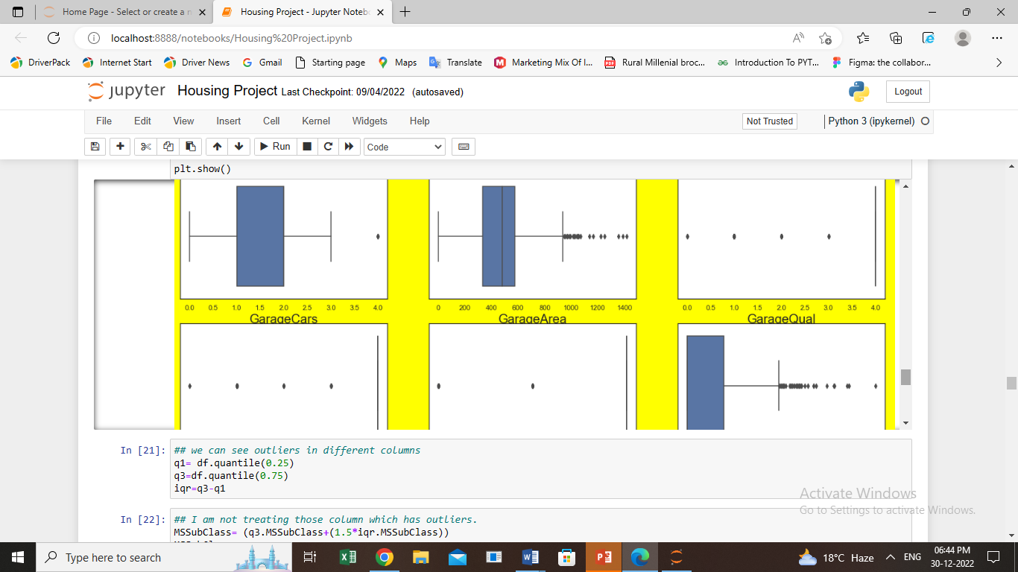

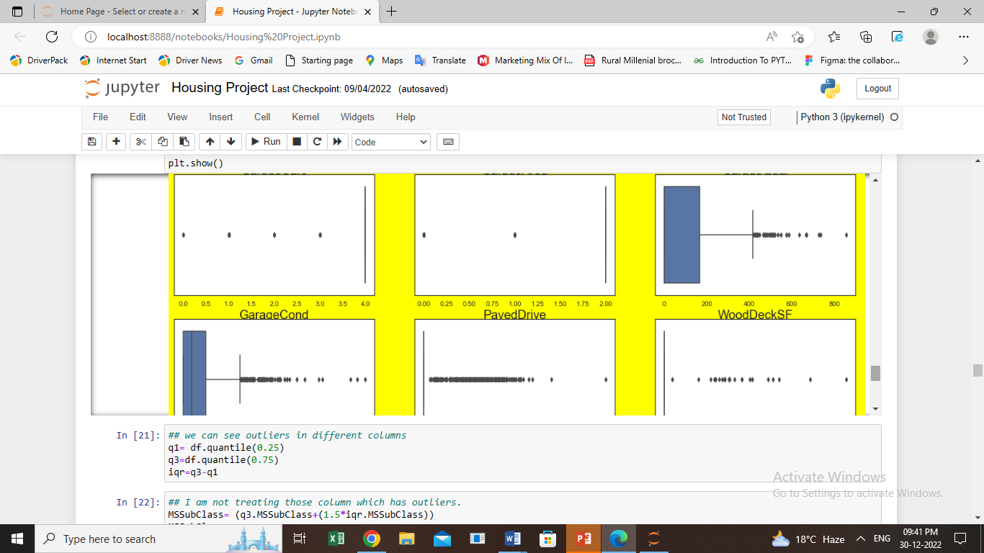

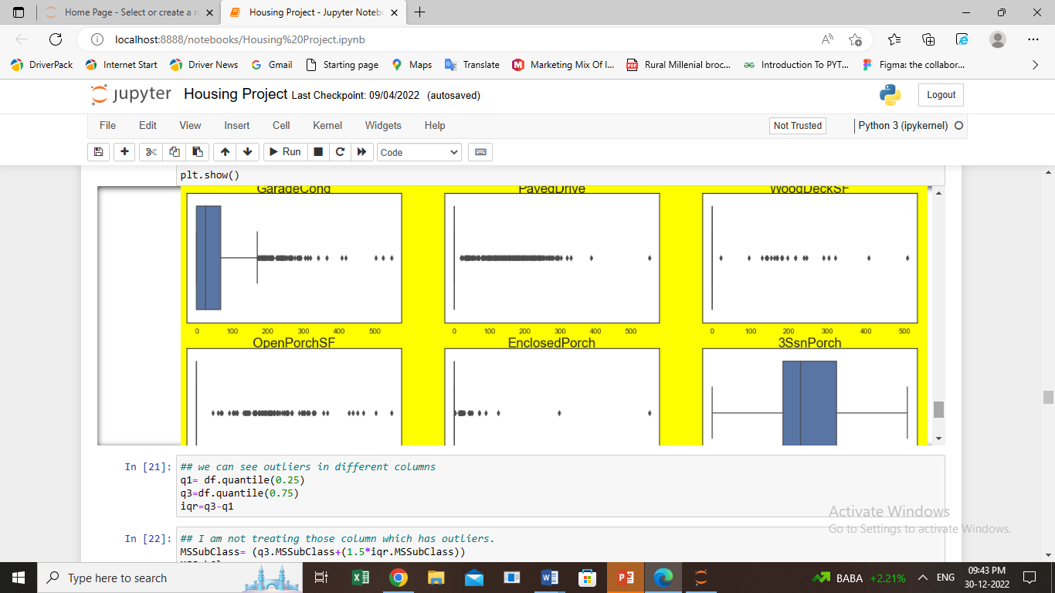

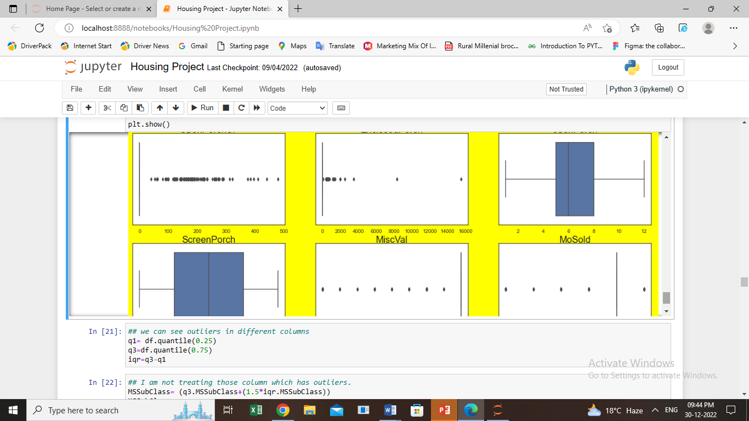

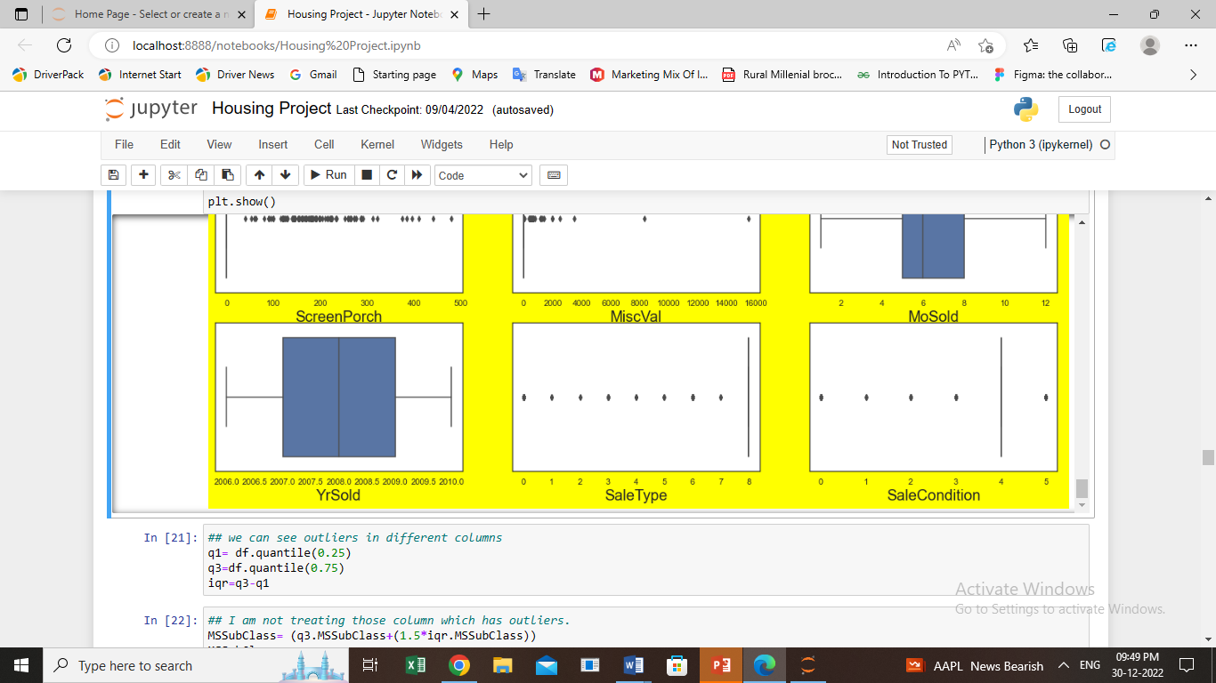

* we can see outliers in different columns like NumCompaniesWorked ,TotalWorkingYears, TrainingTimesLastYear ,YearsAtCompany, YearsInCurrentRole, YearsSinceLastPromotion, YearsWithCurrManager
* q1**=** df**.**quantile(0.25)
* q3**=**df**.**quantile(0.75)
* iqr**=**q3**-**q1
* I am not treating those column which has monetry value as this is going to create impact on the result because it has real values.
* NumCompaniesWorked**=** (q3**.**NumCompaniesWorked**+**(1.5**\***iqr**.**NumCompaniesWorked))

NumCompaniesWorked

index**=** np**.**where(df['NumCompaniesWorked']**>**NumCompaniesWorked)

index

df**=** df**.**drop(df**.**index[index])

df**.**shape

* TotalWorkingYears**=** (q3**.**TotalWorkingYears**+**(1.5**\***iqr**.**TotalWorkingYears))

NumCompaniesWorked

index**=** np**.**where(df['TotalWorkingYears']**>**TotalWorkingYears)

index

df**=** df**.**drop(df**.**index[index])

df**.**shape

* TrainingTimesLastYear**=** (q3**.**TrainingTimesLastYear**+**(1.5**\***iqr**.**TrainingTimesLastYear))

NumCompaniesWorked

index**=** np**.**where(df['TrainingTimesLastYear']**>**TrainingTimesLastYear)

index

df**=** df**.**drop(df**.**index[index])

df**.**shape

* YearsAtCompany**=** (q3**.**YearsAtCompany**+**(1.5**\***iqr**.**YearsAtCompany))

YearsAtCompany

index**=** np**.**where(df['YearsAtCompany']**>**YearsAtCompany)

index

df**=** df**.**drop(df**.**index[index])

df**.**shape

* df**.**reset_index()
* Let’s see how data is distributed.
* plt**.**figure(figsize**=**(20,50))

plotnumber**=**1

**for** column **in** x:

**if** plotnumber**<=**35:

ax**=**plt**.**subplot(12,3,plotnumber)

sns**.**stripplot(y,x[column])

plt**.**xlabel(column,fontsize**=**20)

plotnumber**+=**1

plt**.**show()

* Let’s check correlation of different features with Target variable(Attrition)
* ('Correlation of different features of our dataset with Attrition :')
* **for** i **in** df**.**columns:

corr, _ **=** pearsonr(df[i], df['Attrition'])

print('%s : %.4f' **%**(i,corr))

* Lets do scaling to avoid partiality by model on the basis of number size.
* **from** sklearn.preprocessing **import** StandardScaler

Scaler**=** StandardScaler()

x_scaled**=**Scaler**.**fit_transform(x)

* **from** statsmodels.stats.outliers_influence **import** variance_inflation_factor
* For each X, calculate VIF and save in dataframe

vif **=** pd**.**DataFrame()

vif["VIF Factor"] **=** [variance_inflation_factor(x**.**values, i) **for** i **in** range(x**.**shape[1])]

vif["features"] **=** x**.**columns

vif

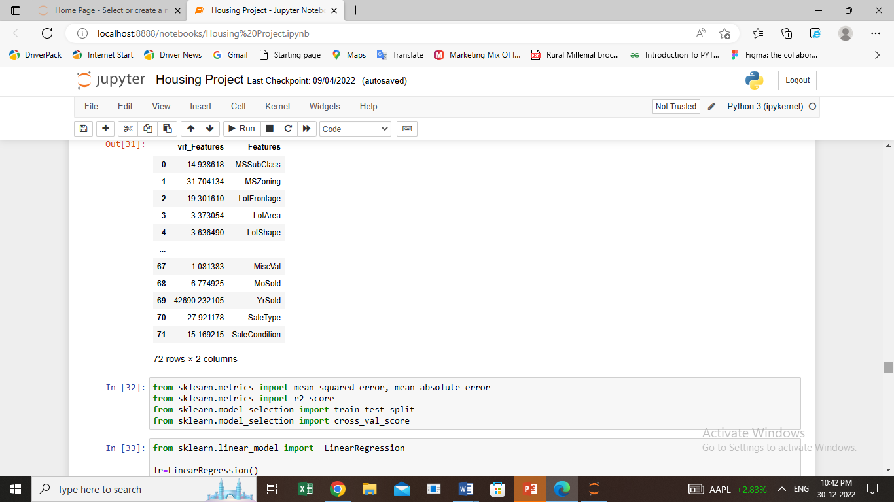

**TESTING OF IDENTIFIED APPROACHES (ALGORITHMS)**

* **Creating training and test set**
* **from** sklearn.model_selection **import** train_test_split
* x_train,x_test,y_train,y_test**=**train_test_split(x,y,test_size**=**0.2,random_state**=**42)
* Feature scaling, but not scaling dependent variable as it has categorical data
* **from** sklearn.preprocessing **import** StandardScaler
* sc **=** StandardScaler()
* Let’s split our data into train and test data

x_train **=** sc**.**fit_transform(x_train)

x_test **=** sc**.**fit_transform(x_test)

**Logistic Regression**

logreg **=** LogisticRegression()

logreg**.**fit(x_train, y_train)

pred_logreg **=** logreg**.**predict(x_test)

Y_compare_logisticRegression **=** pd**.**DataFrame({'Actual' : y_test, 'Predicted' : pred_logreg})

print(Y_compare_logisticRegression**.**sample(5))

* **Confusion matrix**

print('\nConfussion matrix:')

print(confusion_matrix(y_test, pred_logreg))

* We can see confusion matrix, now let’s check Accuracy Score of the model.

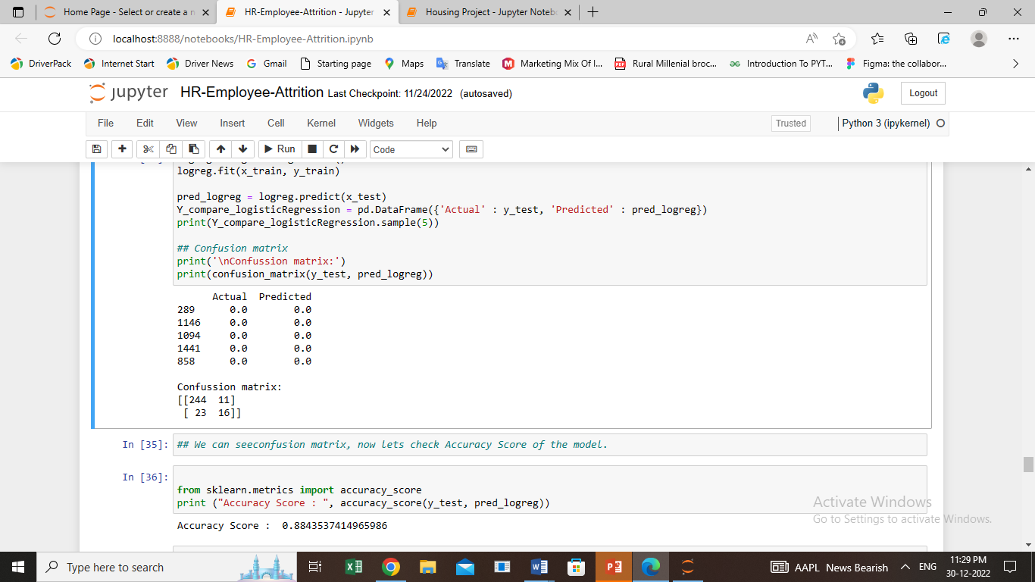

* Lets check the classification matrix
* **from** sklearn.metrics **import** classification_report
* print(classification_report(y_test, pred_logreg))

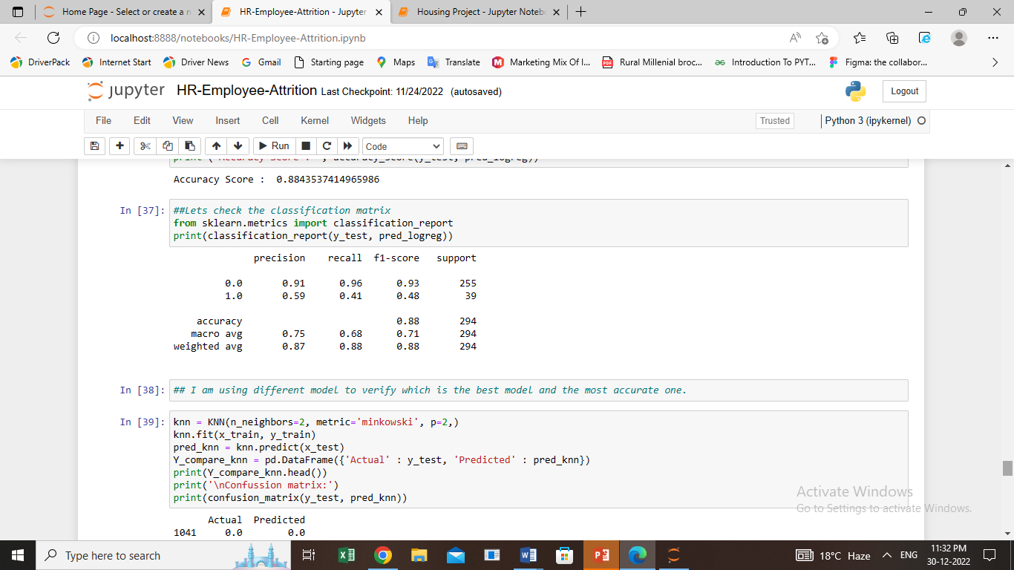

I am using different model to verify which is the best model and the most accurate one.

**KNN**

knn **=** KNN(n_neighbors**=**2, metric**=**'minkowski', p**=**2,)

knn**.**fit(x_train, y_train)

pred_knn **=** knn**.**predict(x_test)

Y_compare_knn **=** pd**.**DataFrame({'Actual' : y_test, 'Predicted' : pred_knn})

print(Y_compare_knn**.**head())

print('\nConfussion matrix:')

print(confusion_matrix(y_test, pred_knn))

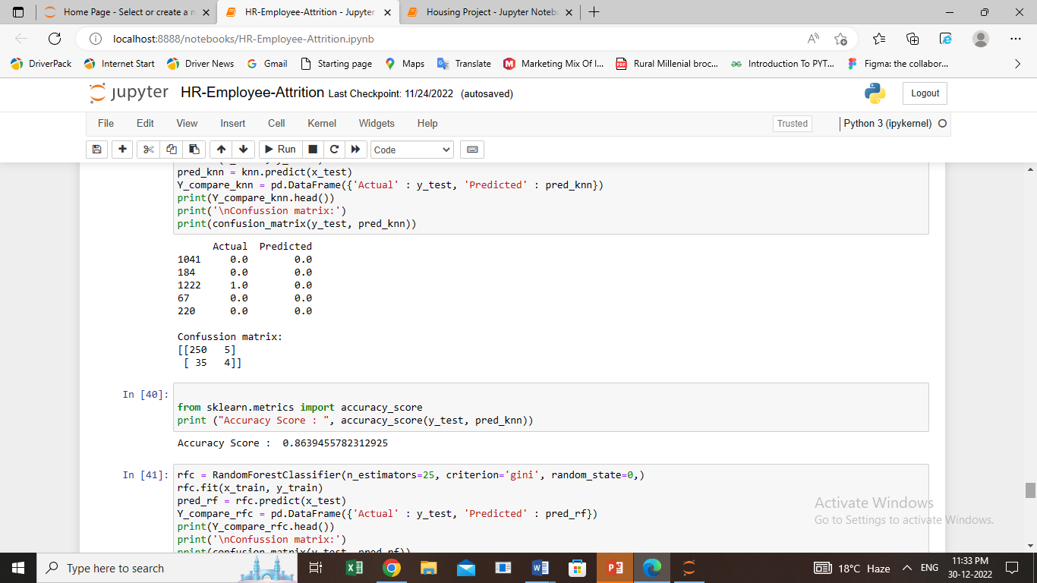

**RANDOM FOREST CLASSIFIER**

rfc **=** RandomForestClassifier(n_estimators**=**25, criterion**=**'gini', random_state**=**0,)

rfc**.**fit(x_train, y_train)

pred_rf **=** rfc**.**predict(x_test)

Y_compare_rfc **=** pd**.**DataFrame({'Actual' : y_test, 'Predicted' : pred_rf})

print(Y_compare_rfc**.**head())

print('\nConfussion matrix:')

print(confusion_matrix(y_test, pred_rf))

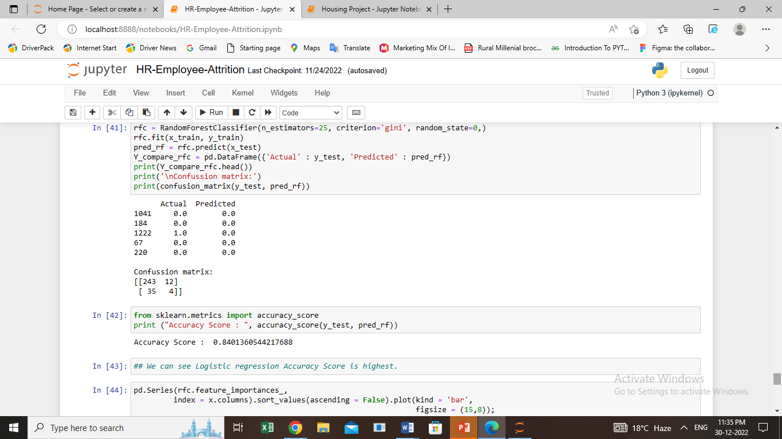

* We can see Logistic regression Accuracy Score is highest.
* pd**.**Series(rfc**.**feature_importances_,

index **=** x**.**columns)**.**sort_values(ascending **=** **False**)**.**plot(kind **=** 'bar',

figsize **=** (15,8));

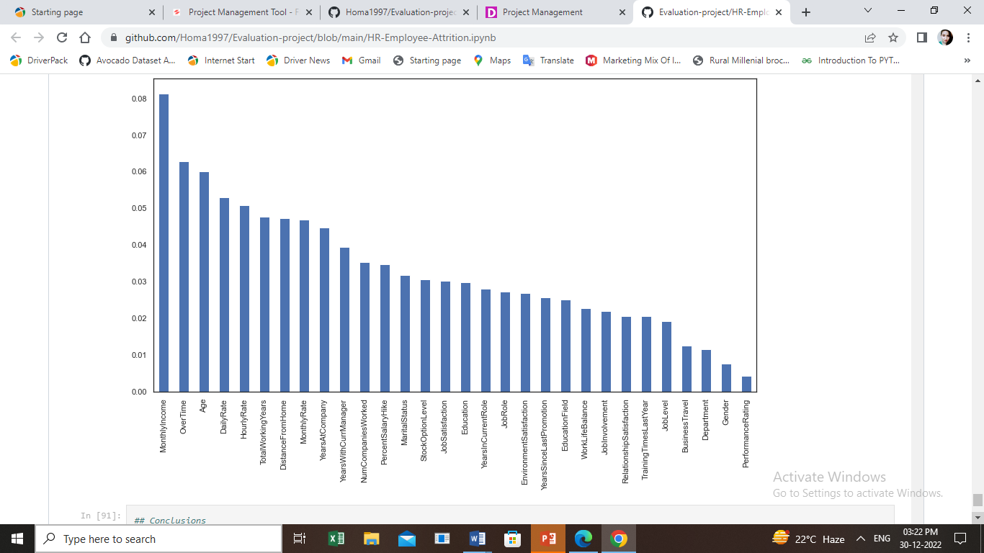

**CONCLUSION**

* I have done EDA using Pandas and other plotting libraries.
* Also made use of packages like matplotlib, plotly and seaborn to develop better insights about the data.
* I also learnt how to create new features which will in turn help us to better predict the survival.
* I get to know what are the features on which price is highly, positively and negatively correlated with.
* I came to know through analysis which model will be work with better accuracy with the help of low residual and RMSE scores.
* This project helped me to understand which model to choose first and go step by step to attain results with good accuracy.
* Also get to know where to use Linear, Decision Tree and other applicable and required models to fine tune the predictions.
* On the basis of above project we can see Logistic Regression has highest Accuracy value and Monthly income is the most important feature which impact